**Get Smart Pa. Kid’s Art Competition**

**Group Event Submission Form**

The 2015 Get Smart Art competition encourages childcare centers to submit their art entries as a group to build awareness and foster discussion. Centers with 70 percent participation will be entered into a drawing for a Kaplan Company gift card. For each child’s entry, please include a parental consent form. Deadline for submission is October 31, 2015, at 10:00 PM(EST). Winners will be notified by November 13, 2015. Completed entries can be scanned and emailed to [knowwhentosayno@pa.gov](mailto:knowwhentosayno@pa.gov) or mailed to:

Get Smart Drawing Competition

Pa. Department of Health

625 Forster St. Room 933

Harrisburg, PA 17120-0701

**Date(s) of participation (MM/DD/YY):** ________________________

**Total number of children in center ages 3-12:** ___________

**Number of children’s entries completed and submitted by the deadline:** _____________

**Name of child care center:**  __________________________________________________

**Street address:** _____________________________________________________________________________

_____________________________________________________________________________

**Email:** ____________________________________________

**Phone number: ____**________________**__________**

**Name of director: Signature of director:**

_______________________________ ______________________________________

I affirm that our childcare center has at least 70 percent participation and would like to be entered into the drawing for a Kaplan Company Gift Certificate.

After the competition, I would like to provide feedback to improve future competitions by receiving a survey to fill out. (Optional, but would be appreciated!)

**C:\Program Files\Microsoft Office\MEDIA\CAGCAT10\j0158007.wmf**[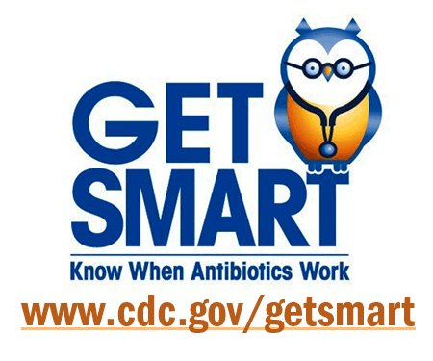](http://www.google.com/url?sa=i&rct=j&q=&esrc=s&frm=1&source=images&cd=&cad=rja&uact=8&docid=ccbwj4uJUPxbPM&tbnid=jX-SQGm2Nr5BNM:&ved=0CAUQjRw&url=http://www.tufts.edu/med/apua/news/cdc-get-smart-week-2011.shtml&ei=bLnGU5TtCoGyyASquYKwAQ&bvm=bv.71126742,d.aWw&psig=AFQjCNGolVC_YfTuKFMtvdwMf5UE_bwU9w&ust=1405618897275296)