**2015 Get Smart Kids’ Competition Guidelines**

Dear parents or legal guardians,

Please read the contest rules and consent form below carefully. If you wish to allow your child to submit an entry, please complete and sign the consent form. Entries can be submitted by email or mail. If you use mail, please include the consent form. For more information, please visit our website at [www.knowwhentosayno.](http://www.knowwhentosayno.)org.

**Submit the entry and consent form by email at:** [**Knowwhentosayno@pa.gov**](mailto:Knowwhentosayno@pa.gov)

**Mailing address:**

**Get Smart Drawing Competition**

**Pa. Department of Health**

**625 Forster St. Room 933**

**Harrisburg, PA 17120-0701**

or

The deadline for submission is October 31, 2015, at 10:00 PM(EST). Winners will be notified by telephone by November 13, 2015. The top three entries in each age group will be awarded a prize. To find examples of past winning entries, please visit our website! If you have any questions, please contact us by email at: [knowwhentosayno@pa.gov](mailto:knowwhentosayno@pa.gov) or by phone at 717-787-3350.

**C:\Documents and Settings\nmueller\Local Settings\Temporary Internet Files\Content.IE5\FLCOI0DO\MC900371340[1].wmfGet Smart Competition Contest Guidelines**

1. Entries will be judged by each age group: <4, 5-6, 7-8, 9-10, 11-12 years old.
2. Only one entry is allowed per child.
3. Each submission must follow at least one of the following themes:
   * Importance of proper hand washing;
   * Importance of vaccines; or
   * C:\Users\amreiff\AppData\Local\Microsoft\Windows\Temporary Internet Files\Content.IE5\9N6RUJTQ\MC900280753[1].wmfKnowing when NOT to use antibiotics. (Hint: such as, common colds … Read our website!)
4. Submission types and guidelines:

* C:\Users\amreiff\AppData\Local\Microsoft\Windows\Temporary Internet Files\Content.IE5\E79E5MRM\MC900432423[1].wmfDrawings
  + For the age groups of: <4yrs, 5-6yrs, 7-8yrs
  + Must be submitted on the template provided
* Informational poster, story, or poem
  + For the age groups: 7-8yrs, 9-10yrs, 11-12yrs.
    - (7-8yr olds are allowed to do any submission.)
  + Posters must fit on a standard paper size (8.5” X 11”) and provide a meaningful message based on one of the themes above.
  + Stories and poems cannot exceed 250 words. They can be a recollection of a personal experience or fictional, also based on one of the themes above.

1. Submissions may be drawn, written by hand, or created using a computer program.
2. Entries must be an original work of the contestant.
3. Children of Department of Health employees cannot participate in this competition.
4. [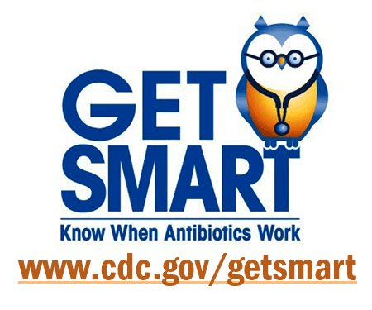](http://www.google.com/url?sa=i&rct=j&q=&esrc=s&frm=1&source=images&cd=&cad=rja&uact=8&docid=ccbwj4uJUPxbPM&tbnid=jX-SQGm2Nr5BNM:&ved=0CAUQjRw&url=http://www.tufts.edu/med/apua/news/cdc-get-smart-week-2011.shtml&ei=bLnGU5TtCoGyyASquYKwAQ&bvm=bv.71126742,d.aWw&psig=AFQjCNGolVC_YfTuKFMtvdwMf5UE_bwU9w&ust=1405618897275296)Most importantly, be creative!

**2015 Get Smart Kids’ Competition**

**Parent Consent Form**

Full name of parent or legal guardian: __________________________________

Child’s full name (contestant): _________________________________________

Date of birth (MM/DD/YY): _______________________ Grade level: _________

Street address: _____________________________________________________

City: ________________________________ State: _____ Zip code:_________

Child is enrolled in a child care center 🞏 No 🞏 Yes (Name of center____________________________)

City State

By checking this box:

1. The contestant has my consent and permission to enter and participate in the 2015 Get Smart Competition.
2. I acknowledge that I have read and understood the attached contest rules. The contestant and I will comply with these contest rules.
3. I allow the contestant’s first name, age, grade level, and entry to be displayed on the program’s website (www.Knowwhentosayno.com) and to be used during the annual National Get Smart Week (November 16-22,2015).

After the competition, I would like to provide feedback to improve future competitions by receiving a survey to fill out. (Optional, but would be appreciated!)

**Parent or legal guardian contact information**

Street address: _____________________________

City, State, Zip: _____________________________

Phone number:_____________________________

Email: ____________________________________

_________________________________ _____________________________

**Signature of parent or legal guardian Date signed**

Privacy Statement: Any personal information provided while participating in this competition or feedback survey will be kept confidential and will not be used, sold or otherwise distributed to third parties.