(Exercises can be found at https://www.med.upenn.edu/bgs/ under Information For…-> New Students-> Overview->BGS Orientation Agenda, Wednesday, August 23)

Get To Know Lab Archives Assignment

Logging in:
- Go to: https://mynotebook.labarchives.com/login
- Sign in through institution
- Choose University of Pennsylvania
- Login with your UPenn credentials

Assignment:
- Create a new Notebook
- Create a folder
- In the folder, create a new document: Rich Text Entry
  - Type your name and date
  - Highlight the date in green
  - Save to page
- In the folder, create a Office document: Presentation
  - Create a title slide of your name
  - Close presentation
  - Navigate folder and open presentation again
- In the folder, add a Plain Text Entry
- Create a subfolder
- In the subfolder, create a document
- In the document, search for a PubMed reference

—-----------------------------------------------------------------------------
These are some of the most common tools you’ll use in LabArchives, but they have many more. Feel free to play around with LabArchives, using the calculator, downloading your notebook into a PDF, searching within the notebook, etc.

OneNote

- Starting OneNote

If you haven’t downloaded Microsoft Office to your computer:
- Navigate to the Microsoft online portal at https://portal.office.com.
- Log in using your @pennmedicine.upenn.edu email address and login credentials
- Click on the drop-down menu that says “Install Apps” and choose “Microsoft 365 apps”

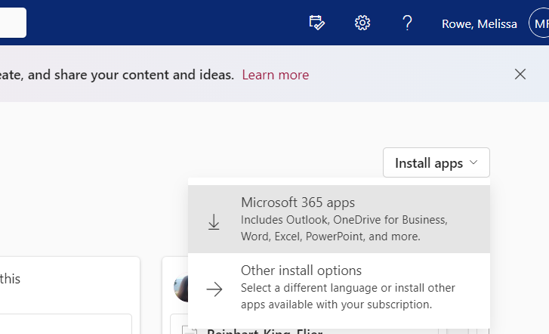

Once Microsoft Office is installed:

- Open OneNote using the purple icon shown here: 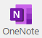

On your own:
- Make and title a new section
- Make and title a new page
- Write something on the page

- While rotating in Dr. Smith’s lab, she asks you to expand a plasmid. You need to transfect the plasmid into E. coli, move the E. coli onto an Amp+ plate, harvest colonies, expand them in LB broth, and do a mini prep on the bacterial culture. Put all of these items in a to-do list on the page you made.

- In that same meeting, Dr. Smith describes the plasmid to you, and you decide to make a rough sketch of it. Use the “Draw” tab to add a hand-drawn shape to the page (a plasmid or your own creation!).

- You just harvested the E. coli colonies. Use the date & time stamp on the “Insert” tab to timestamp that task.

- The “Insert” tab also has several options to insert other files. Try attaching a PDF, both as a printout and as a file attachment (you can use one you already have on your computer or download a PDF from a website like New England Biolabs or Cold Spring Harbor).

- For the next part of your project, you don’t want to manually make a to-do list. Click on Page Templates and try adding one of the templates under “Planners”.

- At the end of your rotation, Dr. Smith asks you to share your lab notebook with the lab manager. Export the section you just made to a OneNote file and to a PDF. (Hint: The Export options are under the File tab).

- If you have time, explore some of the other features! Some options you can try out are: adding notebook lines to a page, turning hand-drawn objects into text shapes or equations, and adding stickers.

Intro to Benchling Exercises
New Users:
1. Navigate to: https://benchling.com/signup/welcome
2. Sign up for an account and verify email address.
3. Follow prompts to explore the notebook and molecular biology tools.
4. When you finish exploring one option, you can find the other by clicking the checkbox icon in the bottom left.

If already a user:
- Login to your account

Explore the Notebook:
- Open a Project.
Navigate to (or search for) "Example Project" or any saved project.

- Create a new entry.
Click + on the left then "Blank entry" to create an entry from scratch.

- Create and edit a table.
Insert a table and try using a formula.

- Insert a New Day.
Find "New Day" in the Insert menu in the top toolbar.

- Link a sequence.
Type "@pBR322_EGFR" (or another saved sequence) to mention a sequence in your entry.

- Add a protocol to your entry.
Click add a protocol and select one.

Explore Molecular Biology:
- Open a sequence.
Navigate to "Example Project" or another saved project and open "pBR322_EGFR" or another saved sequence.
If no sequences are saved, continue to step 6 and then return.

- Split your workspace
Click "Split Workspace" below this to see a plasmid map alongside the sequence map.

- Add annotations
  - Click on the Annotations button - the first gray button on the right side panel.
  - Click "Auto-annotate" to search for a pre-populated library of annotation features.
  - Search for the “Default Features” library.
  - Add the two matching features to the sequence as annotations by clicking "Add Annotations."

- Run a digest
  - Click on the Digests button - the gray scissors on the right side panel.
  - Under "Find Enzyme," click to select two restriction enzymes in the list.
  - Click "Run Digest."
  - To see virtual results, click the "Virtual Digest" tab toward the top of your screen.

- View an alignment
  - Click on the Alignments button on the right side panel.
  - Find "Saved Alignments" - a history of all other alignments performed against this sequence.
  - Click on the saved alignment to open and view the results of example sequencing preps.

- Import a new sequence
  - Click "+" on the left then "DNA / RNA Sequence" and "New DNA / RNA Sequence."
  - Find the "Search External Databases" tab to search for a sequence from a database.
  - Import the sequence you searched for!

