How to order a medication/infusion in CHPS outpatient department (Non-oncology Providers)
- Make sure you login under department 1115
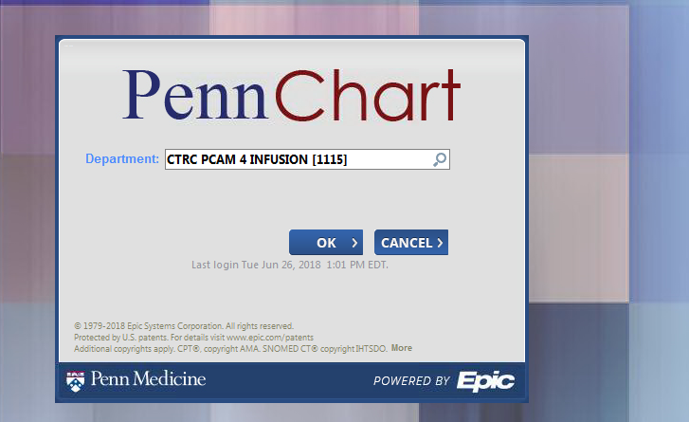
- Open up an “orders only” encounter
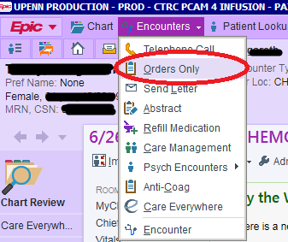

- Click on inverted triangle (1), then many users will have to click on “Rarely used” (2) at the bottom of the list and then on “Beacon Treatment Plans” (3)
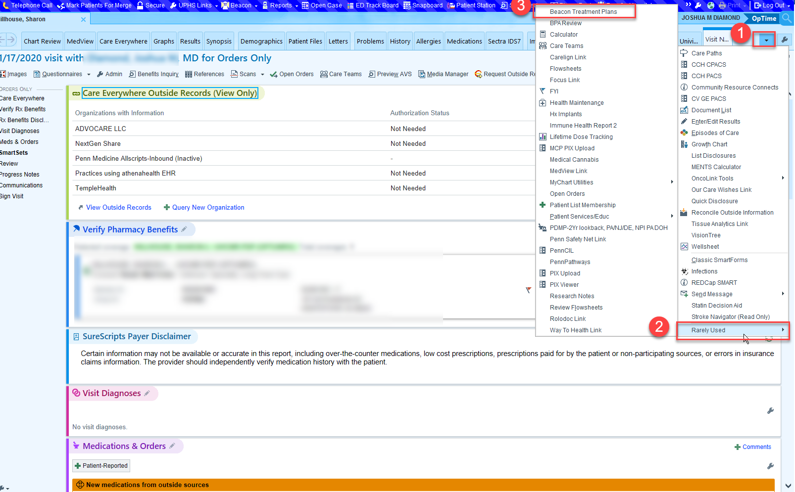
- Select “Non-Oncology Plan” under Beacon Treatment Plans
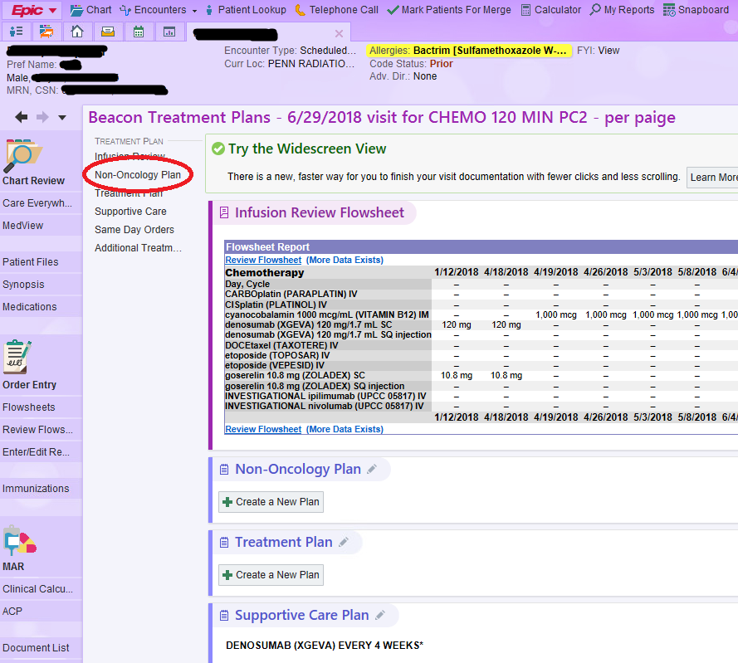

- Select Create a New Plan

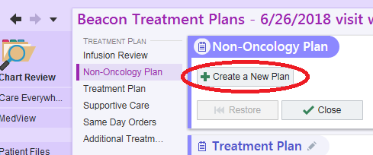

- Select Create Blank Plan
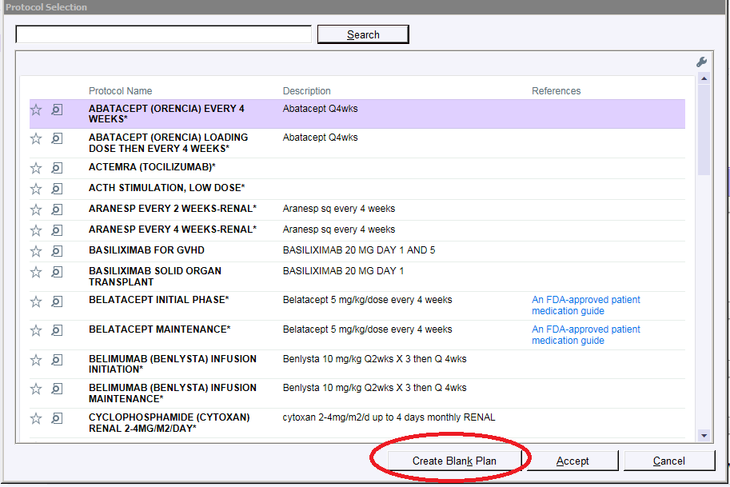

- Enter Protocol Name, and Treatment start date should reflect encounter date in CHPS
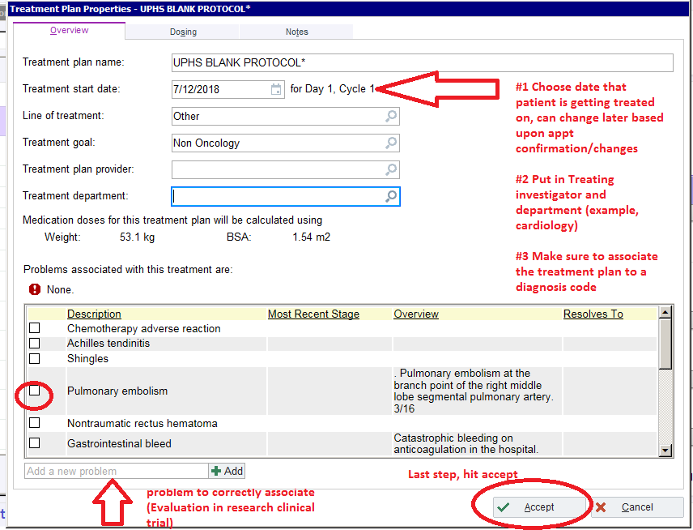

- Add oral or infusion orders through this functionality. Input any Lab, Treatment, or nursing specific instructions in the free text fields of the appropriate header.

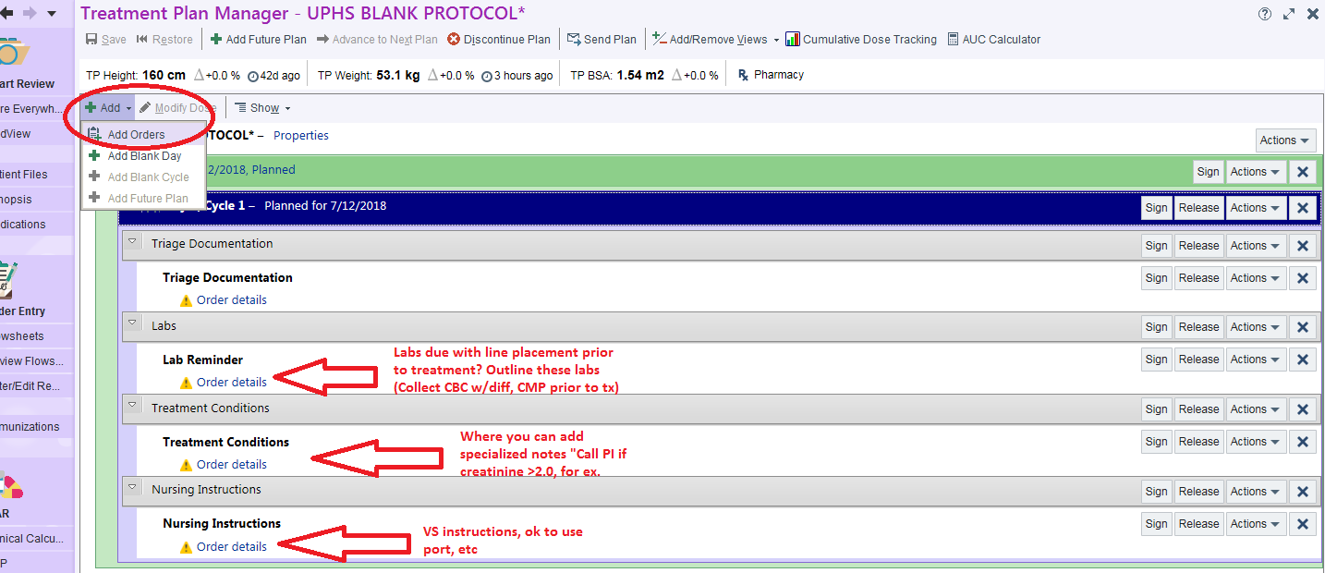
- Select non-formulary under “Add orders” function, click appropriate route of investigational agent.

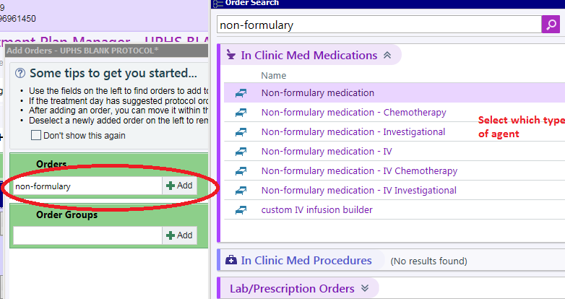

- Input Investigational agent/Drug information below, as well as route and any specific administration instructions.
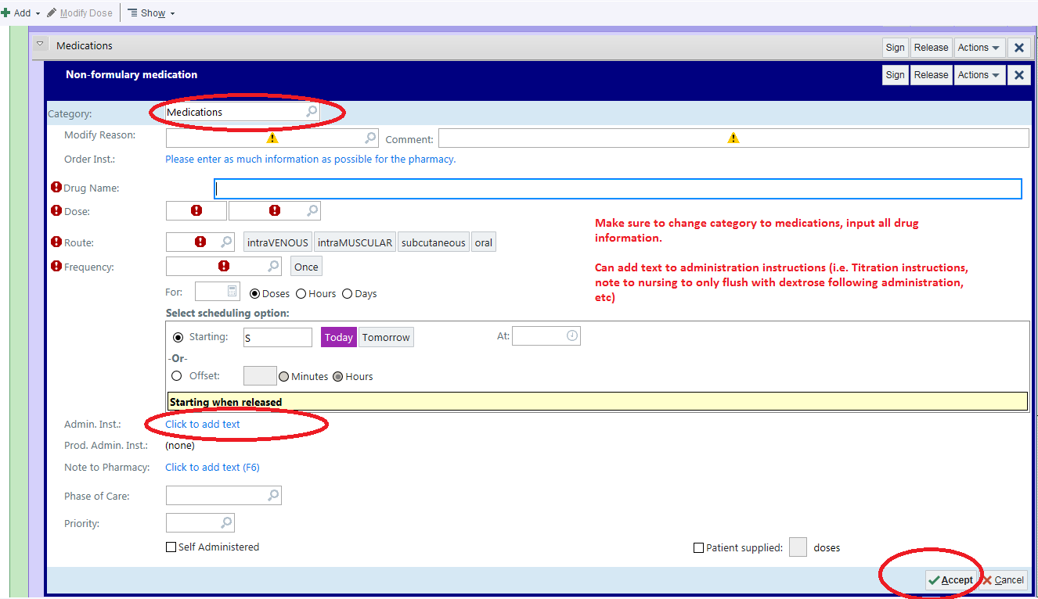
- If you are a MD/APP you can Sign the entire care plan, so that the drugs can be routed in EPIC to the pharmacy to prepare, and the nurses will sign out administration timing in the eMAR. If you are a Research RN or CRC, you must send the plan to the treating investigator via their EPIC inbasket to sign off on order set.
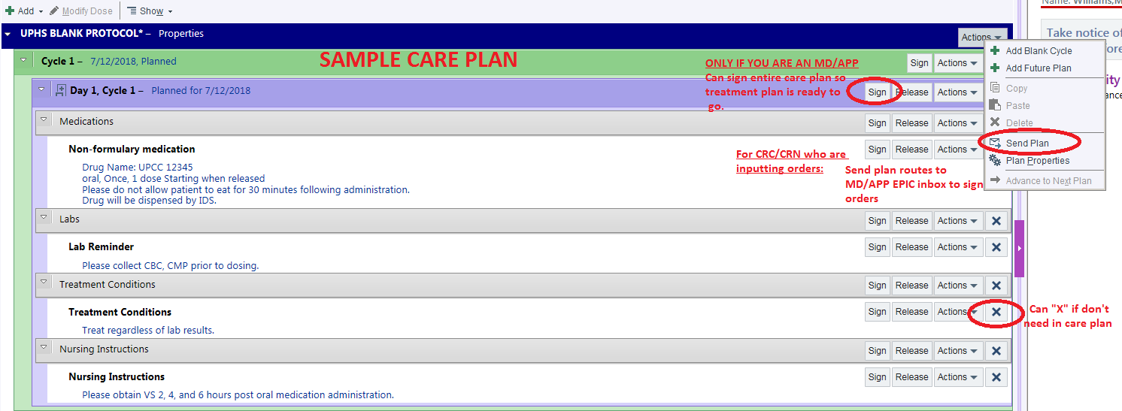

- If you are a CRC or Research RN, once you hit “Send Plan” (as illustrated in the picture above), you can then input the PI/Treating investigator information as shown below.
