Introducing LoxP insertion in mice using CIRSPR/Cas9

REAGENTS

pX335 plasmid (Addgene # 42335), used for sgRNA in vitro transcription

Custom-designed ssDNA (Integrated DNA Technologies): Resuspend and dilute ssDNA in RNase-free water at a final concentration of 1 ug/ul, store the stock at -20C.

ssDNA (160nt):

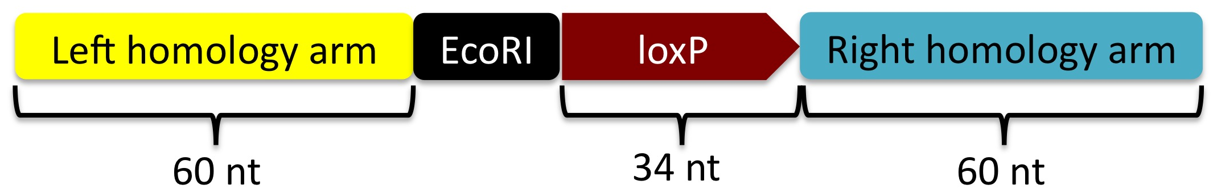

loxP: 5’-ataacttcgtatagcatacattatacgaagttat-3’

(Note: Core sequence highlighted in red dictates the orientation of loxP sequence)

A Restriction site (EcoRI as an example) is added to allow downstream genotyping (StepXX).

T7 High Yield RNA Synthesis Kit (NEB, cat. No.E2040S)

MEGAclear kit (Life Technologies, cat. no. AM1908)

QIAQuick PCR purification kit (Qiagen, cat. No. 28106)

QIAQuick Gel Extraction kit (Qiagen, cat. No. 28704)

TA Cloning kit (Invitrogen, cat. no. 450641)

Phusion high-fidelity DNA polymerase (NEB, cat. no. M0530)

GoTaq Green Master Mix for PCR (Promega cat. No. M7121) for genotyping PCR

NID buffer for genomic DNA extraction from mouse tail biopsies

50 mM KCl

10 mM Tris pH8.3

2 mM MgCl₂

0.1 mg/ml gelatin

0.45% NP 40

0.45% Tween 20

Add 1.2 μl 10 mg/ml Proteinase K to every 200 μl of NID buffer right before use

Cas9 mRNA (5meC, Ψ), 1 μg/ul (Trilink, cat. No. L-6125)

Before the first use of the Cas9 mRNA, centrifuge at the top speed at 4 °C for 20 minutes and then transfer suspension to a new RNAse-free tube (leaving 10-15 ul in the original tube). Repeat the centrifugation, aliquot the supernatant and store at -80 °C.
 CRITICAL STEP If the Cas9 mRNA is not centrifuged as described above, the needles for microinjection will be clogged.

SCR7 (Xcessbio, cat. No. M60082-2s), to inhibit NHEJ
https://www.xcessbio.com/products/small-molecules/SCR7.html): Dissolve in DMSO to make 50 mM stock, aliquot and freeze at -20 °C.

PROCEDURE
In vitro transcription and purification of sgRNA ✪ TIMING 2 d
1| For sgRNA preparation, add the T7 sequence to the sgRNA template by PCR amplification using the appropriate primer sets.

Primers:

T7-sgRNA-F: 5’-TTAATACGACTCACTATAGGNNNNNNNNNNNNNNNNNNNNgttttagagctagaaatagc-3’

Green: 20-nt sgRNA guide sequence

Orange: T7 promoter, the additional T is to aid polymerase binding.

Black: sequence complementary to part of pX335.
For sgRNA design and construction, follow the protocol described by Feng Zhang’s laboratory at the link below:
http://www.genome-engineering.org/crispr/?page_id=41

sgRNA-R: 5’-AGCACCGACTCGGTGCCACT-3’

- PCR reaction:
Component | Amount (μl/reaction)
5X Phusion HF Buffer | 20
10mM dNTPs | 2
10uM Primer Mix | 5
DNA Polymerase | 1
Template DNA (pX335), 10 ng | 2
H2O | 70
Total Volume | 100

- PCR cycling parameters:
Cycle number | Denature | Anneal & Extend | Final Extend
1 | 98 °C, 30s
2-34 | 98 °C, 30s | 72 °C, 20s
35 |  |  | 72 °C, 1 min
Hold at 4 °C

3| Nanodrop the PCR products for concentrations, run 50 ng PCR product on a 2% agarose gel to verify that the PCR product is unique and of the expected size (~ 117bp).

4| Gel-purify the T7-sgRNA PCR product using the QIAQuick Gel Extraction kit according to the manufacturer’s instructions, elute in 30 μl RNase free water. (Typical concentration of PCR product ranges from 40 to 70 ng/μl)

5| Use the gel-purified T7-sgRNA PCR product as the template for in vitro transcription of sgRNA using the T7 High Yield RNA Synthesis kit according to the kit protocol.
- Set up in vitro transcription reaction as follow:

Component | Amount (μl/reaction)
10X Reaction Buffer | 1.5
ATP | 1.5
GTP | 1.5
UTP | 1.5
CTP | 1.5
Template DNA (500 ng) | X
T7 RNA polymerase Mix | 1.5
Nuclease-free H2O | X
Total | 20

Incubate at 37 °C for minimum 4 hours or overnight.

6| Purify the sgRNA using the MEGAclear kit according to the kit protocol. Preheat elution buffer at 95°C and elute twice with 50 μl buffer each. Combine the two elutes to get 100 μl of the sgRNA.

7| Centrifuge the eluted sgRNA at the top speed at 4 °C for 20 minutes and then transfer suspension to a new RNAse-free tube (leaving 10-15 ul in the original tube). Repeat the centrifugation and measure the concentration of the purified sgRNA.

Dilute the sgRNA to 500 ng/ul in injection buffer (10 mM Tris / 0.1 mM EDTA, pH 7.5 prepared with sterile water). Aliquot and store the purified sgRNA in -80 °C.

 CRITICAL STEP If the eluted sgRNA are not centrifuged as described above, the needles for microinjection will be clogged.

8| To assess the quality of the purified sgRNA, run 1 μl on a total RNA Nano Chip using bioanalyzer (See an example of typical bioanalyzer result below).

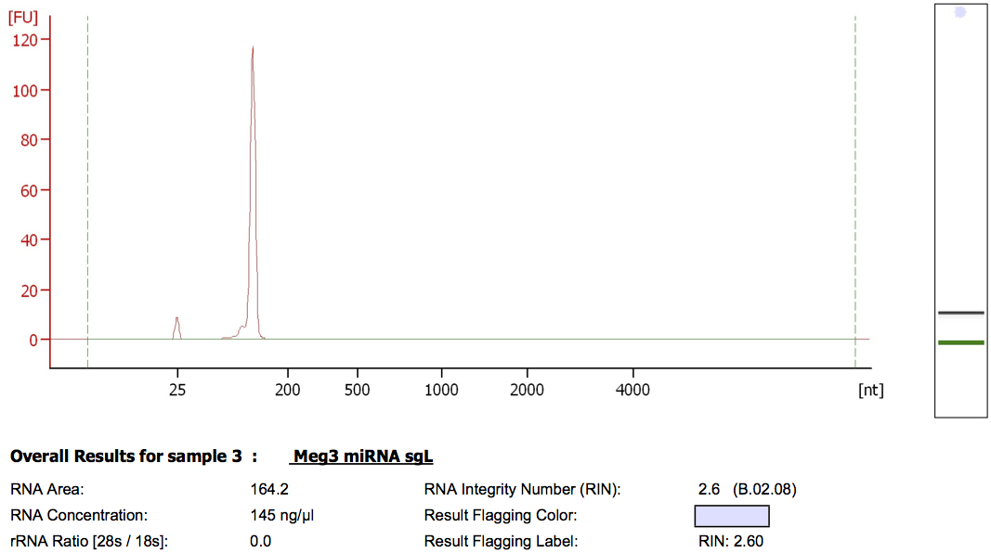

Note: Smeared bands from electropherograms indicate degradation. Samples should be discarded if degradation is observed.

Preparation of the injection mix ✪ TIMING 1 h

9| Right before injection, prepare the injection mix on ice as outlined in the table below.

Component | Stock Concentration | Stock Vol. (ul) | Final Concentration
ssDNA for left loxP | 1 μg/μl | 3 | 100 ng/μl
ssDNA for right loxP | 1 μg/μl | 3 | 100 ng/μl
sgRNA (Left) | 500 ng/μl | 3 | 50 ng/μl
sgRNA (Right) | 500 ng/μl | 3 | 50 ng/μl
Cas9 mRNA | 1 μg/μl | 3 | 100 ng/μl
Injection buffer |  | 15
Total |  | 30

Optional: spin the injection mix at the top speed at 4 °C for 20 min. Leave a few μl of solution at the bottom, transfer the rest to a new RNase-free tube for injection.

Cytoplasmic zygote injection, embryo transfer and production of mice are performed by the Transgenic & Chimeric Mouse Facility at Penn. ✪ TIMING 3 wks
10| To enhance HDR, SCR7 is added to the overnight egg culture at the final concentration of 50 μM (1000 fold dilution of stock).
 CRITICAL STEP Use freshly thawed SCR7 aliquot from -20 °C ONLY. SCR7 stored at 4 °C for a few weeks seems to impair egg survival.

Genotyping ✪ TIMING 4 d
11| To extract genomic DNA, digest tail biopsie of a 3-week-old mouse with 200 μl NID buffer (freshly supplemented with proteinase K) at 56 °C overnight, then inactivate the proteinase K at 95 °C for 10 min. Use 3 μl of the lysate for the genotyping PCR reaction.
Component | Amount (μl/reaction)
Tail DNA | 3
Primer mix (10 μM for each primer) | 3
GoTaq Green PCR Master Mix | 30
H2O | 24
Total | 60

Cycle number | Denature | Anneal | Extend
1 | 95 °C, 4 min
2-34 | 95 °C, 35 s | 60 °C, 35 s | 72 °C, 50 s
35 |  |  | 72 °C, 7 min
Hold at 4 °C

12| Purify the PCR products by using the QIAQuick PCR purification kit, digest with designed the restriction enzyme and run an agarose gel to check digestion pattern. The PCR product from the targeted allele should bear the restriction site. While the PCR product from the untargeted allele remains uncut upon enzyme treatment.
13 | Clone the PCR products using the TA cloning kit and verify the insertion by sequencing.

