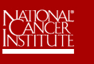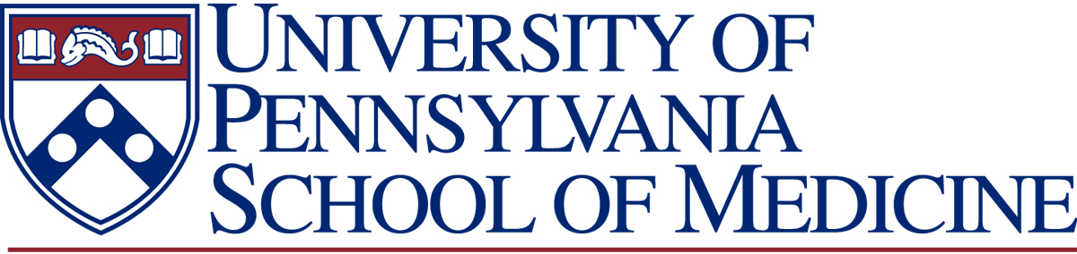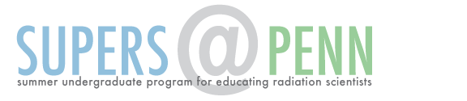

RECOMMENDATION LETTER
Name of Applicant:

The student named above has applied for a SUPERS@PENN summer research internship. SUPERS@PENN is an NCI/NIH funded initiative specifically aimed at talented undergraduates who have a genuine interest in pursuing an advanced degree (Ph.D. or M.D., Ph.D.) with the ultimate goal of a career in medical research. The program provides training for students interested in the disciplines of Radiation and Cancer Biology, Radiation Physics or Cancer Imaging and Bioengineering. Funding is available for up to two consecutive summers, rising juniors and seniors will be considered.

Please complete the following two questions using a scale of 1-5 (1-highly recommended to 5-not recommended):

Likelihood that of student will pursue an advanced degree (Ph.D or equivalent), and ultimately a research career.

(1)______ (2) ______ (3) ______ (4) ______ (5)______

Overall Recommendation: (Please rate from 1-highly recommended to 5-not recommended):

(1)______ (2) ______ (3) ______ (4) ______ (5)______

Recommender’s name: Signature:

Position and Title:

Date:

On official letterhead, please provide, to the best of your ability, your overall assessment of the candidate’s abilities with regard to the following: (a) Performance in science courses. (b) Performance in the research laboratory setting. (c) Motivation and commitment towards a career in medical research. Letter should be attached to this cover sheet. Completed recommendations should be submitted as an email attachment, SUPERS@uphs.upenn.edu Alternately forms can be faxed to the attention of Dr Tuttle at 215-898-0090. Recommendation are due in hand by February 3, 2017.

