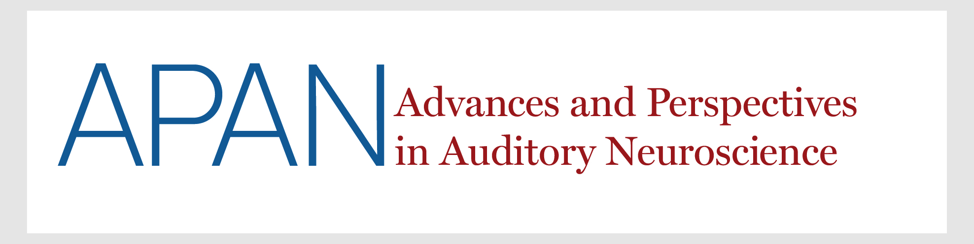

_________________ has paid _____ dollars for registration for the 2022 Symposium on Advances and Perspectives in Auditory Neuroscience that was held on November 11, 2022 in San Diego, CA

