VMHDS Core iLabs account information

The Viral Molecular High Density Sequencing (VMHDS) core uses the iLabs system to track service requests and manage billing.

https://med-upenn.corefacilities.org/service_center/show_external/5129?name=viral-molecular-high-density-sequencing-core#

You will need to create an account by visiting this site and clicking the link in the upper right corner:

Instructions for creating an account can be found here:
Penn users:
https://www.med.upenn.edu/cores/registering-for-an-ilab-account-penn-faculty-and-staff.pdf
Non-Penn users:
https://help.ilab.agilent.com/99540-getting-started-with-ilab/325013-registering-with-ilab

External for-profit customers please note: Once your account is created we need to manually adjust to a for-profit account. Please let us know when you create the account before creating a service request.

Once you have created an account please visit our core iLabs page to submit a request:
https://med-upenn.corefacilities.org/service_center/show_external/5129?name=viral-molecular-high-density-sequencing-core

- Navigate to the Request Services tab.
- Click “Initiate request” under Request Services. 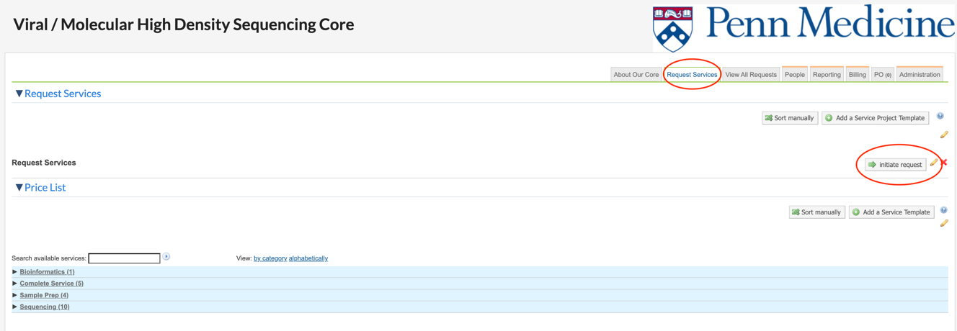

- Write a brief description of the aims of the study.
- Choose “complete service package”, and INSPIIRED (integration site analysis) or iGUIDE (crispr off-target analysis).
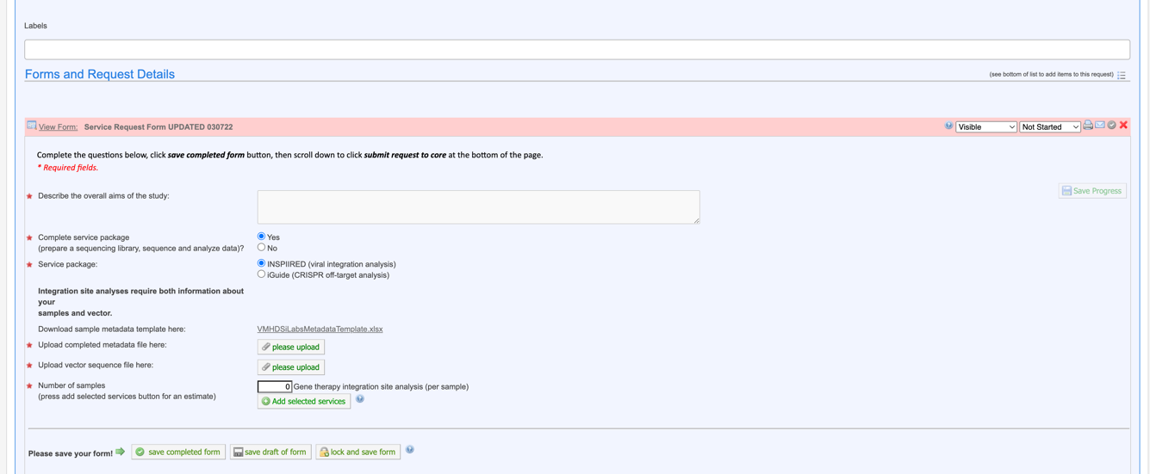

- Upload the metadata and vector map if needed (blank documents will suffice if we already have this information).
- Add number of samples and click “add selected services” - then submit.

Once we receive a request we will send a quote for services to allow for a PO to be generated.
When POs are available, please upload them to the iLabs system (under the PO tab).

If you have any questions or problems please contact our Technical Director, Aoife Doto: rochea@upenn.edu

TROUBLESHOOTING
If you are having trouble viewing our Penn core from your institution iLab account please try the following:
- Login to iLab with your Institution Account
- Update the “View” menu on your core facilities page to “Cores at Other Institutions”
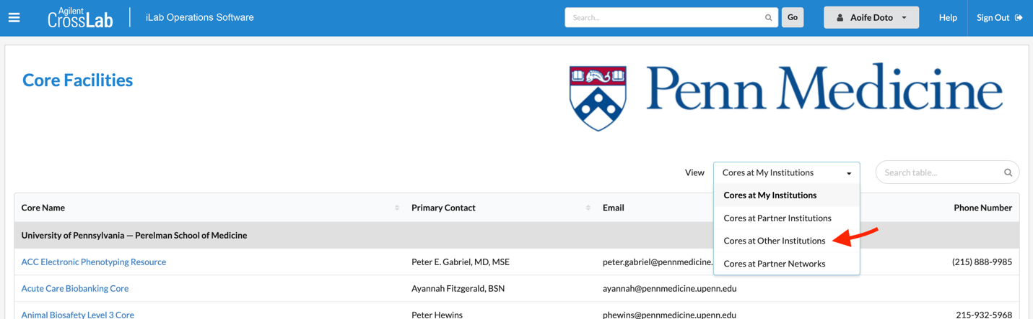
- Search for the “Viral Molecular High Density Sequencing” Core

