Rounding checklist
Front desk staff will round every 2 hours in the waiting room and complete the following punch list items:

Waiting room/Common areas:
☐ All appropriate waiting room chairs have “do not sit” signage and remain 6ft apart.
☐ Floor markers (tape, stickers, etc.) remain intact and visible.
☐ No magazines or pamphlets out on the tables.
☐ All patients are wearing masks and adhering to social distancing requirements.
☐ (Wear appropriate PPE) wipe down vacant chairs and commonly touched surfaces. Wet-dust horizontal surfaces by using a cloth moistened with a small amount of an EPA-registered disinfectant
☐ (Wear appropriate PPE) Wipe down the counter tops. Concentrate on cleaning high-touch surfaces (areas frequently touched by patients and facility staff).
☐ Check bathrooms to make sure they are clean. If dirty, please contact EVS.
☐ Breakrooms and touchdown areas are clean and employees adhere to social distancing requirements.

Exam Rooms/Infusion bays:
- Change the paper covering the exam table and pillows between patient use

- Place any used linens (e.g., exam gowns, sheets) in a designated container located in each exam room after each patient use.

- Clean any medication preparation area after each patient encounter and ensure contaminated items (as described above) are not placed in or near the area.

- Focus cleaning on high-touch surfaces (at least daily), e.g., exam bed, blood pressure cuff, stethoscope, wall-mounted ophthalmoscope and otoscope (per manufacturer’s instructions), chair and bedside stool, and door knob. Adhere to dwell time instructions on the product label.

- For electronics such as cell phones, tablets, touch screens, and keyboards, remove visible contamination if present. If no manufacturer guidance is available, e use of alcohol-based wipes containing at least 70% alcohol to disinfect touch screens. Dry surfaces thoroughly to avoid pooling of liquids.

- Decontaminate high-touch surfaces using an EPA-registered disinfectant with specific claim labels for the infective agent.

  - List N: EPA-registered disinfectants that have qualified under EPA’s emerging viral pathogens program for use against SARS-CoV-2

- If patient has suspected infectious diarrhea and the infective agent is unknown, clean high-touch surfaces using a sodium hypochlorite (bleach)-based product (e.g., 1:10 dilution prepared fresh)

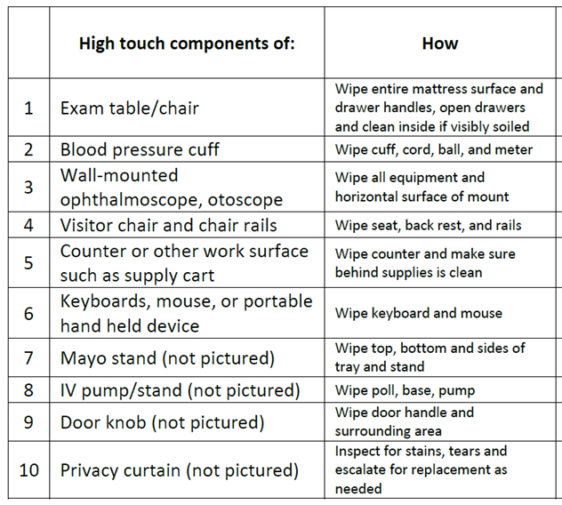

**Complete separate audit form and submit to manager

