WARNING:
It would only take 2-3 milligrams of fentanyl to cause breathing to stop, your heart to stop, and possibly death. 2-3 milligrams of fentanyl is about the same size as five individual grains of table salt (see photo below).

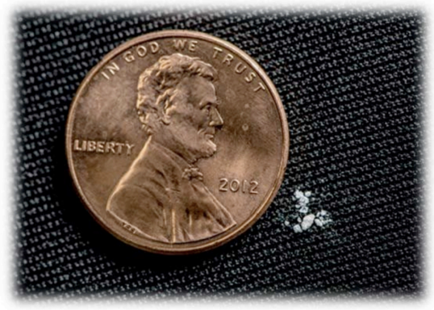
LOCAL COCAINE MAY CONTAIN FENTANYL
Fentanyl is a synthetic opioid that is 50-100 times as potent as morphine; even a tiny amount can quickly cause breathing to stop, leading to cardiac arrest (heart stopping) and death unless naloxone (Narcan) is given.
From the Philadelphia Department of Public Health (PDPH):
From June 16-26, 2018, the Philadelphia Department of Public Health (PDPH) identified an increase in unintentional drug-related overdoses in the Haverford North, Mantua, and Powelton Village neighborhoods of West Philadelphia. 20 individuals have had overdoses, including two fatalities.
Some experienced brain injury due to lack of oxygen, and cardiac arrest. Most thought they were smoking only crack cocaine but their symptoms indicated opioid overdose, raising the concern of possible fentanyl in the cocaine. Some overdose cases had ONLY fentanyl in their system, suggesting that the only active drug in the ‘rock’ sold as cocaine was actually fentanyl. Emergency personnel needed to use much higher doses of naloxone than usual to produce a reversal of overdose symptoms – this is common with fentanyl overdose.

What can YOU do to reduce the likelihood of a fatal FENTANYL overdose?
The only way to completely protect yourself is to avoid drug use. However, if you are still using, there are some important steps you can take to reduce your risk:

- Treatment*
Minimize your risk by reducing your use of cocaine or heroin – as these can now contain fentanyl in lethal amounts. Intensify your ongoing treatment, or get back into treatment in order to prevent relapse – and possible overdose.
Behavioral Health Services Initiative (uninsured): 1-215-546-1200
Community Behavioral Health (Medicaid): 1-888-545-2600 http://dbhids.org/addiction-services/

*FREE cocaine treatment is available for those eligible to participate in cocaine medication trials at the UPENN School of Medicine, Center for Studies on Addiction: 1-215-746-3708

- Reversing an (Opioid) Overdose Learn about naloxone, the medication used to reverse opioid overdose. You, your friends, and family can learn more about naloxone at www.phillynaloxone.com. Emergency Naloxone Kits are available through Overdose Prevention (overdose.prevention@phila.gov). Keep one nearby. Fentanyl overdose is near-instant. Administer the naloxone, and call 911 to request additional help.
- Harm Reduction Learn about harm reduction approaches to use of drugs, including never using alone, keeping naloxone nearby, using very small amounts first, and testing your drugs for fentanyl (with ‘dip strips’) -- prior to using. Prevention Point (2913 Kensington Avenue) has begun to make these testing strips available. Local: https://ppponline.org/ 215-634-5272 National: http://harmreduction.org/drugs-and-drug-users/drug-tools/getting-off-right/

