Department of Medicine
Greenphire Guidance for Study Teams within DOM
**Alternative to AP checks, gift cards and petty cash for subject remuneration.
Process
- Requesting ClinCards
  - An electronic request to utilize ClinCard is submitted through a link on the Accounts Payable Web-site: (https://www.finance.upenn.edu/Disbursements-Accounts-Payable)
  - Greenphire can be accessed on the below “Greenphire Clincard” tab and by Submitting your Request by using the appropriate button
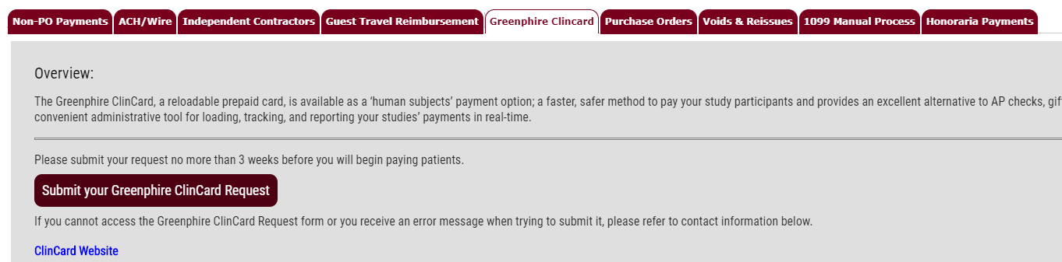
  - It is anticipated that the Study Team will be initiating the request.
    - Requestor is required to indicate:
        - New or Existing study
        - IRB Protocol Number
        - Study Nickname
        - # of cards being requested
        - Branded or Generic cards
        - Estimated Budget
        - Name and Email of Business Administrator
(if managed by CRS- Timothy Marino / timothy.marino@pennmedicine.upenn.edu)
        - Duration of Study (in months)
    - Requestor should be precise on the Payment Schedule (visit/milestone amount)
    - Requestor should populate the full 26-digit for payments (and Reimbursements if utilized)
    - To complete the form, add the following personnel who will have a role, in the Comments/Notes at the bottom of the request form:
      - Coordinator/s - registers subjects in Greenphire and makes payments (list those CRCs applicable for the study)
Approver (identify BA/Grants Manager) - Any manual payment or reimbursement of $100 or more must be approved before the money is issued to the subject on their ClinCard.
Reports- List Timothy Marino (DOM), timothy.marino@pennmedicine.upenn.edu (Add additional business staff, as needed)
*One person can have one type of access, all three, or any combination.
  - Business Administrator’s name and email are required to be supplied.
Accounts Payable will send an email to the BA requesting s/he to authorize the request.
  - A delegate approver will need to be identified for payments greater than $100 that are not listed within the Payment Schedule as part of the original request. Stipend payments that are listed on the payment schedule can be up to $700/visit/milestone. This would not require a delegate approver to authorize.
  - Once the request receives BA approval, cards will likely be available for pick-up within 24 hours. An email will be sent to the requestor to indicate that the requested card/s are available.
- Distributing/Loading ClinCards
  - When distributing a ClinCard to the subject, a signed C2 form (listing the ClinCard #) and W9 will be required to be collected (current process) and submitted to Accounts Payable.
  - Before registering and providing a subject with a ClinCard, CRC’s should search “All” to ensure that subject is not already set up and have a ClinCard for use.
  - CRCs will be able to log-in and load money onto the subjects’ cards as visits/milestones are completed.
  - AP will post a monthly journal to include all charges as one lump sum to each specific study. Reports are available, through Greenphire, that will break-down the lump sum and provide specific detail.
    - Access to the system is needed for Central/BA level. CRCs will have access to this feature.
Reporting
- Various reporting metrics are available through Greenphire that will provide back-up for audits. In order to run reports, access is needed.
General Notes
- Foreign nationals cannot utilize this form of reimbursement.
- Within initial IRB application, fees/method of payment will need to be identified and described.
  - An IRB modification will need to be submitted for any active study wanting to use ClinCard for their compensation mechanism.
- Back-up Travel documents will need to be kept by division for study related travel reimbursements paid through ClinCard.

