Requesting a Research Billing Number (RBN)

**Important Notes Before Submitting**
- The study MUST be created in CTMS before requesting a RBN
- The study MUST have an IRB status of “Approved” in the system

Submission Process
- Go to: https://www.med.upenn.edu/apps/my_dot_med
- Login using your PennKey & PennKey password
- Under the header ‘Research Support’ (top right of screen), select ‘Research Billing Application (RBA)’
- Select “Submit a new request” (see below)

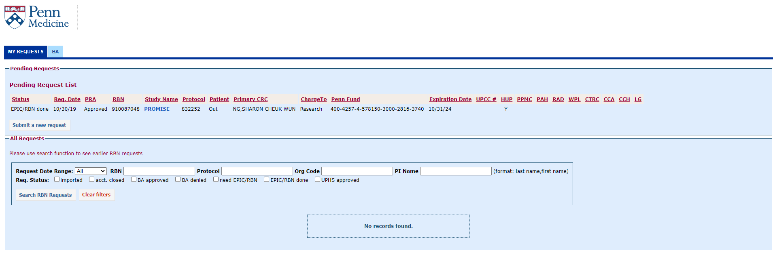
- Fill out the required sections and click “Submit” in the bottom left corner.
- Your RBN request has been submitted!

Next Steps:
- An auto-generated email will be sent to the appropriate BA to approve the RBN request. This involves linking the protocol (IRB#) to the study. Regarding #2 above, if the project is not fully “Approved,” in the system, your BA will not be able to move forward until it is.
- Your BA will also link the account (fund) to the IRB project number.
- Once BA-approved, OCR will review the PRA and, upon approval, issue a Research Billing Number.

