Downloading Our Meeting App:
Our course meeting app is available for download in both the App Store and Google Play. To download the app, type in “Penn Radiology” in your search bar and our Penn Radiology Meetings & Events icon should pop up. Once the app is downloaded, click the “Open” button.
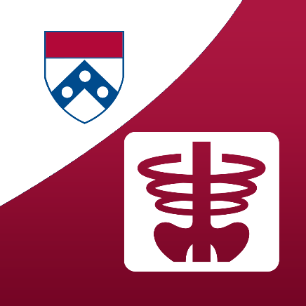

The below page should now appear. Click the “Open” or download button next to our course title. Enter the password “Fully3D” to begin logging into the app.
Please click “Allow” for to receive meeting notifications. Follow the log-in instructions by entering your first and last name. Then click “Next.” The next screen will require you to enter a verification code that will be sent to your email on file. Navigate to your inbox and enter the code from the email in the app. Then click “Verify.”

Enter in any additional information that you would like to appear in your attendee profile, or click “Skip” and complete at a later time. Once complete, click “Log In.”
Congratulations! You should now be successfully logged into the app! Tap on the icons to view the conference schedule, view our list of speakers, and find out more information about our course location including dining options and activities.

