Grishchuk lab, Upenn
January 2020
Quantitative analysis of dense granules and intracellular calcium in individual platelets
Tools:
- Origin
- Matlab
- ImageJ

Analysis is done in several steps:
- Platelet selection & generation of curves of mepacrine fluorescence intensity versus time for each platelet.
- Platelet selection & generation of curves of Calbryte-590^{AM} fluorescence intensity versus time for each platelet.
- Recalculation from mepacrine fluorescence intensity to number of dense granules for each platelet.
- Recalculation from number of frames to time (in seconds). Definition of time of activator entry.
- Program analysis of dense granule release and Calcium oscillations in single platelets.

- Platelet selection & generation of curves of mepacrine fluorescence intensity versus time for each platelet.
Step 1 – Platelet selection
- Platelets are chosen, using both Transmitted light photo (Figure 1) and video of Mepacrine channel (Figure 2).
- Platelet selection criteria:
- Platelet contains granules
- Platelet did not move out of the field
- Platelet is not close to other platelets, so its granules could not be distinguished.
- 10-20 platelets are randomly chosen from different parts of the field.
- Numbers of platelets are marked on the first frame of the mepacrine channel video (Figure 3).
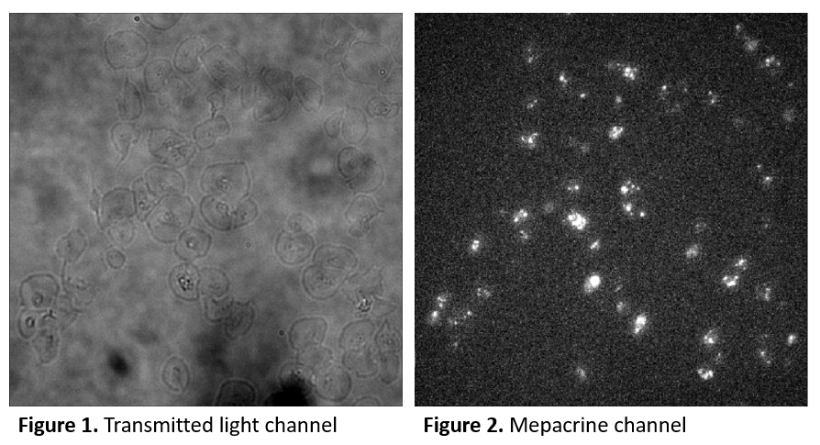
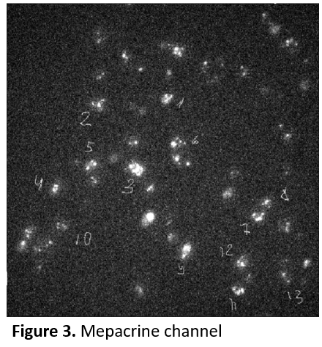
Step 2 – Single platelet analysis
- In each platelet region of minimal area (shown by yellow curve in Figure 5) is chosen by eye. This region should contain all granules of a platelet during whole experiment.
- Total mepacrine intensity of selected region versus # of frame is calculated (Figure 5).
- Outside of the platelet total intensity of a region of the same area (Figure 6) versus frame is calculated and then linearly fitted (Figure 7).
- Total intensity of selected region (linearly fitted) outside of the platelet is background signal that is subtracted from total mepacrine intensity of selected area inside the platelet (Figure 8). Obtained curve is a mepacrine intensity of dense granules in a platelet versus number of frame.
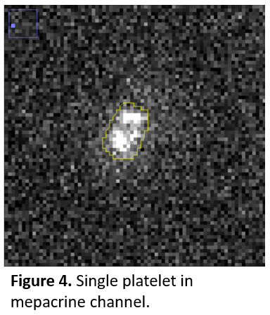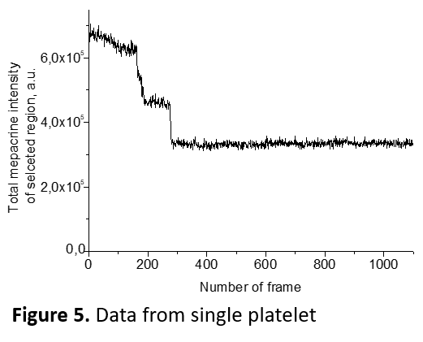

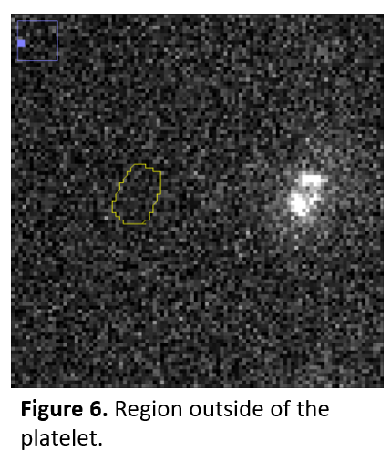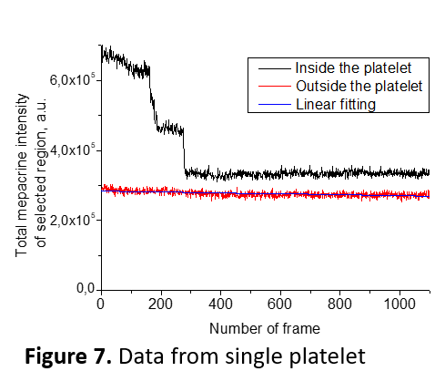
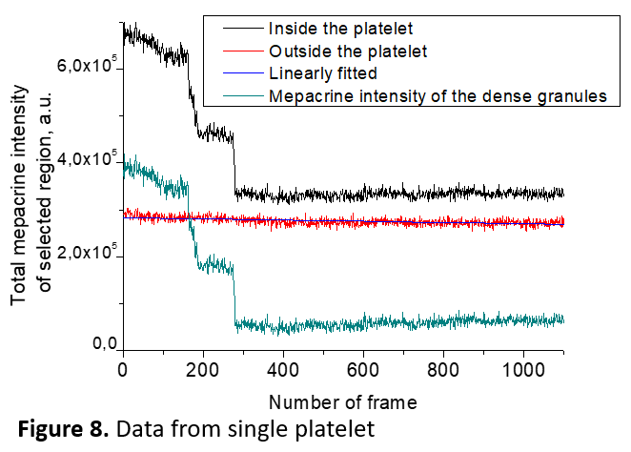

- Platelet selection & generation of curves of Calbryte-590^{AM} fluorescence intensity versus time for each platelet.
Step 1 – Platelet selection
- For the same platelet chosen for dense granule analysis, determine Calbryte-590^{AM} fluorescence in single platelets.
Step 2 – Single platelet analysis
- Choose the region of the same area (as was chosen for platelet dense granule) or smaller in the same platelet (shown by yellow curve in Figures 9 and 10).
- Calculate mean pixel intensity of Calbryte-590^{AM} fluorescence of this region versus number of frame (Figure 11).
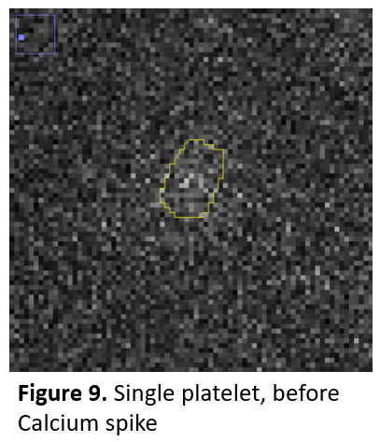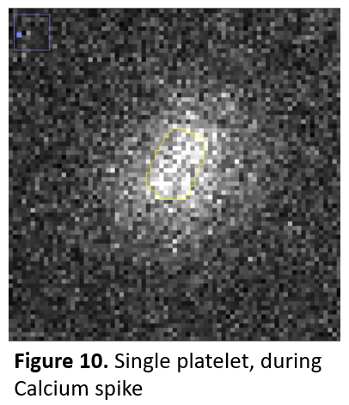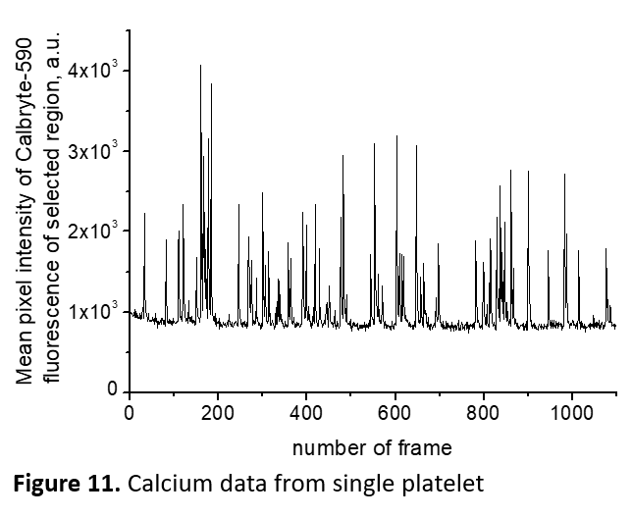

- Recalculation from Mepacrine fluorescence intensity to number of dense granules for each platelet.
- Each value is divided on median number of single granule fluorescence intensity (Figure 12).
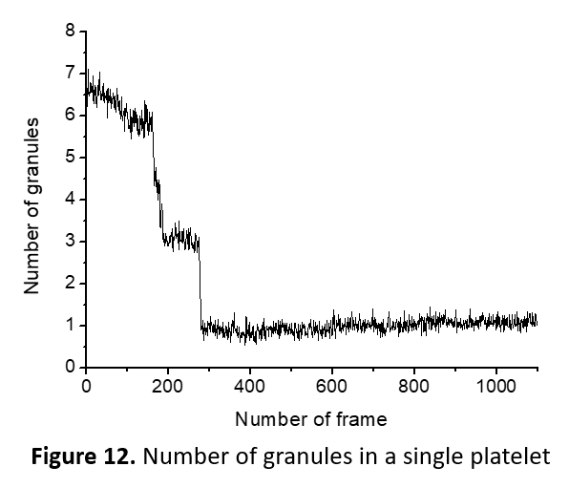
- Recalculation from number of frames to time (in seconds). Definition of time of activator entry.
- Because there is a certain length of tubes and flow chamber channel used in experiment some time is needed for activator to reach platelets in the channel. This time was calculated as following:
Length of the inward tube = 60 mm
Inner diameter of the tube = 0.6 mm
½ of the channel length = 6,5 mm
Width of the channel = 1 mm
Height of the channel = 0.05 mm
Rate of the solutions = 25 ul/min
V – total volume
Q – volume rate of flow
T=V/Q=(60*(0.3)²*3.14+6.5*1*0.05)/25*60 = 41.5 seconds
- Time of activator entry (0 s) = Time of addition of buffer with activator to Eppendorf (after start of measurement) + 41.5 seconds
- Mean frame per second rate is 2, then time between frames is 0.5 seconds.
- Number of frames is replaced by time of experiment (Figure 13)
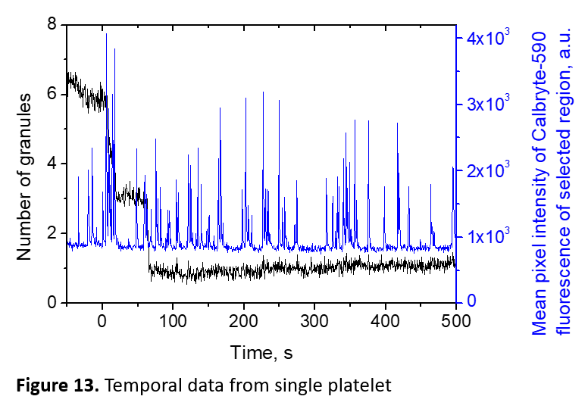

- Program analysis of dense granule release and Calcium oscillations in single platelets
Use Matlab code called: Quantitative analysis of kinetics of dense granule secretion and calcium oscillations in individual platelets
Step 1 – Transferring data
- Transfer data for one experiment to txt file in the following format.
Time, s | Selected region area for Calcium analysis for platelet #1 | Mean pixel intensity of Calbryte-590^{AM} fluorescence of selected area  for platelet #1 | Selected region area for Dense granule analysis  for platelet #1 | Number of granules for platelet #1 | Spread or unspread state of platelet #1 | Selected region area for Calcium analysis for platelet #2 | …

- Write in program number of platelets (m) and number of frames (n).
- Analyze platelets one by one.
- Looking together video of a single platelet and its curve of dense granule number versus time, determine number of release events.
- Determine 4 points (manually) for 1st release event (Figure 14):
1 – point that is so far from 2nd point so between them there is a “plateau”
2 – frame before platelet started to release granules
3 – frame when intensity of mepacrine fluorescence stopped to fail by eye and in the curve, this point is within 4 seconds (8 frames) from the 2nd point
4 – point is so far from 3^{d} point so between them there is a “plateau”
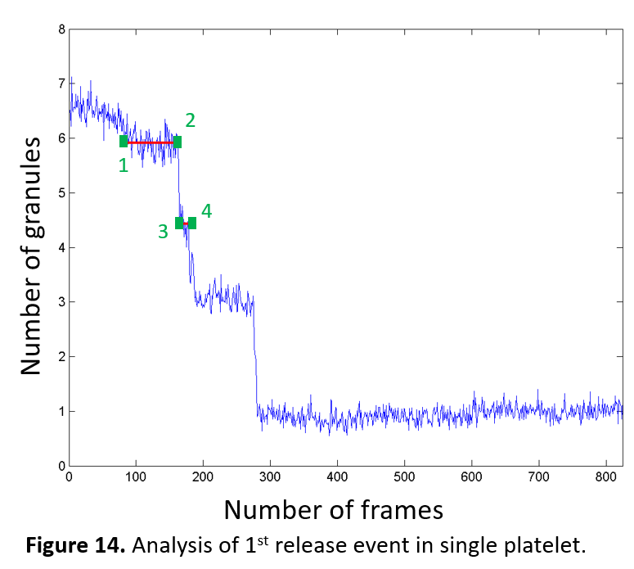
Time of 1st granule release start = time of point 2
Number of released granules = (averaged number granules from point 1 to point 2) – (averaged number of granules from point 3 to point 4)
Duration of 1st release (seconds) = (time of point 3 - time of point 2)
- Determine baseline of the Calcium curve (Mean pixel intensity of Calbryte-590^{AM} fluorescence of selected area versus time). In program baseline curve (shown by red line) is calculated by linear approximation of 5-7 points (shown by red squares) manually chosen on Calcium curve (shown by blue line) between Calcium spikes (Figure 15). This linear baseline curve is then subtracted from Calcium curve.
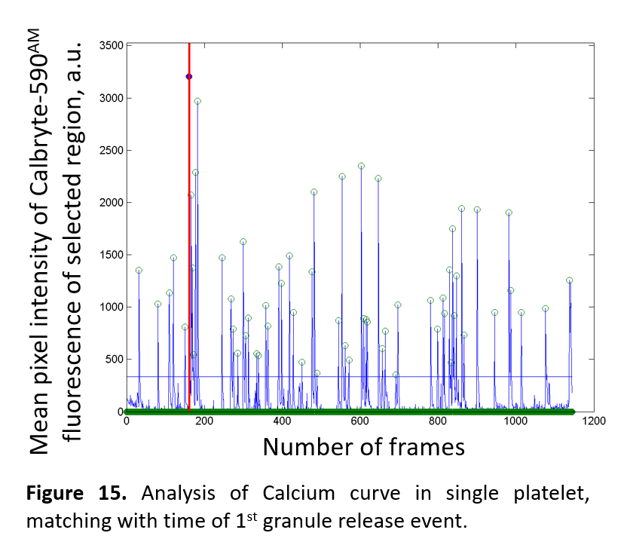
- Determine Critical Calcium level on the Calcium curve to define Calcium spikes. The linear curve, which is parallel to baseline curve is determined manually (shown by blue curve in Figure 16). Calcium spikes are shown by green open circles.
- Program calculate different parameters relatively a) to time of activator entry, b) to time of 1st granule release event start (shown by red line in Figure 16), like “last Calcium spike” (shown by blue filled circle) which directly precedes dense granule 1st granule release event start.
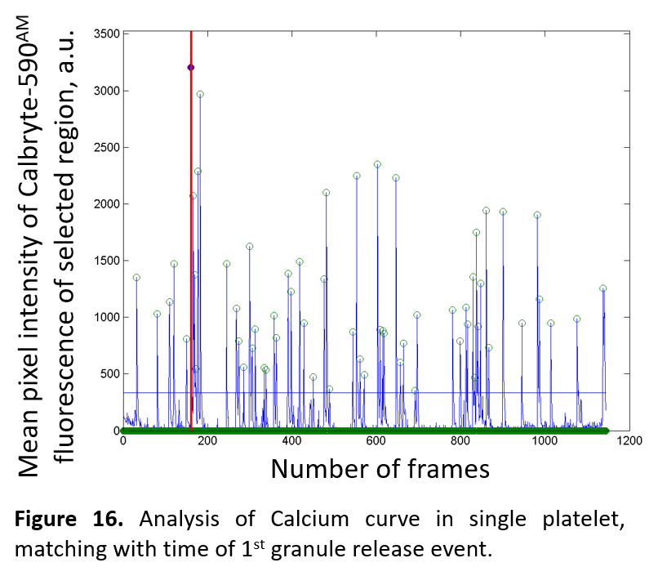
- The output of the program is several files:
- 3 pictures (like Figures 14, 15, 16)
- Table with data of dense granule release and Calcium spikes.
- Table with data of Calcium spikes.
- Table with data of Calcium integrals and Bootstrap model

For the protocol 2019.12.23_3_exp_4_plt was chosen as an example. This experiment was done in accordance with Protocol # 3 - Measurement of dense granules and intracellular Calcium in platelets in blood based flow chamber experiment

