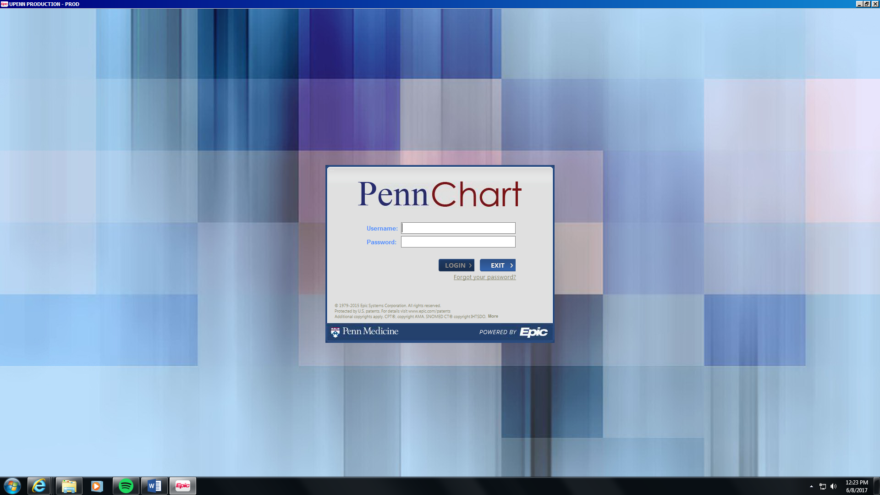

**Checklist for EPIC Inpatient Workflow**

**Flint Wang, MD**

**To access the EPIC/PennChart playground test environment: (no syncing in training environment to Medview or Carelign):**

-From the UPHS Intranet (using logging in via <https://pennmedaccess.uphs.upenn.edu> and using the DuoMobile authentication), go to “Applications via Citrix” and click on “Detect Receiver” and then “Accept” and then “Already Downloaded”. If you accidentally click on “Use Light Version” you have to restart your computer to erase those settings.

-Click on the blue “PennChart-Training Playground” where the icon says PLY (playground)

-Do not use your real login for the Training Playground. Login username: “PULXX” and password “train” where the XX is a number 01-24 for example “PUL15” and “train”. If someone else is practicing at the same time just choose a different number.

-Environment is “HUP Internal Medicine Virtual”

-**In this training view you can write fake notes and place fake orders but only a few test patients actually exist. Also, the training playground is only updated every few years so the view looks slightly different than the current live EPIC.**

**Patients you can practice on:**

-Go to the Top Left where it says “EPIC” and click on “Patient Care” and “Hospital Chart”

-In the patient name section you can just type in Romulus, Edward or Perseus, Edward as examples that have an inpatient encounter.

**SIGNING IN FOR EXISTING PATIENTS**

1. Top left section click on the icon with the patient with three yellow lines
2. Under “Available Lists” click on “HUP System Lists” or “PPMC System Lists” aka Presby. Note that PAH refers to Pennsylvania Hospital (different residency program)
3. Click on “Provider Teams – Medicine – HUP”
4. Select the team you will be starting on: ex) “Medicine HUP, Martin 1A”
5. For the team you will be starting on you also want to select the Incoming version of that list (bed management will automatically put new admissions into this list and it is up to you and your resident to distribute it between interns). For example the above intern would select “Medicine HUP, Martin 1 Incoming” and also “Medicine HUP, Martin 1 All” and potentially also “Medicine HUP, Martin 1B and 1C” to include your co-intern and sub-I.
6. You select each of these lists by right clicking on the list name and click “Send to: Rounding List”
7. Now when you click on the list you can click in the top left “Sign In” to sign in as covering provider in the morning for the whole list rather than doing it for each individual patient.
8. Note that you must type in your cell phone number (otherwise defaults to your department’s front desk number) and select 16 hours as your sign-in length. If you choose 12 hours and the next covering provider signs in even a second after 12hrs, the covering provider slot disappears and the nurses won’t know who to reach for questions.

**ADMITTING A PATIENT**

1. Find the patient in PennChart by clicking on “Hospital Chart”
2. Right click on the name to:
   1. Assign the team: example: HUP Medicine, Martin 1A

Add yourself as covering provider and reassign the attending name if needed

1. Click on “Notes” and then “ED Notes” to read the ED clinical course so far and “Consults” for any consultant notes from the ED
2. Click on “Admission” from the left menu bar
3. Click on Review PTA (prior to admission aka home) Meds
   1. Add a home med that is not currently listed
   2. Click on either “Today” “Yesterday” or “Unknown” for when the patient last took the medication, click on the red “X” to delete the medication if erroneous
4. Click on “Admission Orders”
   1. It will first bring you to “Review Current Orders” but go back to “Review Home Medications”
   2. Choose to Continue, Discontinue, or Modify home meds
   3. Click on “Review Current Orders” (these are usually the ED ones). Choose to Continue, Discontinue, or Modify these. You are choosing which of these should be continued after the patient arrives up to the floor.
   4. Click on “Reconcile Home Medications” to ensure you did not duplicate between the Review Current Orders section and the Home Meds section
   5. Click on “New Orders” (remember if you enter orders here they will not be activated until the patient physically leaves the ED to come to the floor, so if you want a stat dose of antibiotics or insulin you would finish off the whole admission order set and then put the antibiotic/insulin order in as a stat order separately)
      1. Under Order Sets and Pathways, type in “Admission” and search. Go to “Medical Admission Order Set IP Gen Med” (IP stands for inpatient)
      2. Choose code status, admitting team and attending, diet, frequency of vital signs, etc. And then close out the order set. DO NOT select the patient’s floor status as “CCH-Telemetry”. That is an erroneous order that will actually shuttle the patient to the Chester County Hospital queue line. You will just click on either “Med/Surg” or “Intensive Care” and then put in a separate telemetry order.
      3. Under “Place New Orders” click “+New Order”
         1. Add additional orders here like telemetry, nebulizers, standing antibiotics that can wait until the patient comes the floor, etc.
      4. Go to “Review and Sign”. These orders will be “Signed and Held” meaning the nurse will activate the orders when the patient arrives on the floor. However generally we go ahead and activate these orders given prolonged periods where patients stay in the ED before they get a room. Again, if you want a stat order to go in you should not place it within the admissions order set. You should finish the admission orders and then go back into the orders section and place a stat order. This is important for routing of physical medications to either the ED or the floor on arrival.
      5. Remember that things like subcutaneous insulin, Coumadin, heparin subQ and therapeutic dosing, etc come as order sets only, not as individual orders.
      6. **Note that as a student you cannot sign orders so you will Save Work or Pend them so your senior resident or an intern can sign them.**
5. Creating the EPIC/PennChart admission note
   1. In PennChart click on “Notes”, go to the H&P section, and click on “New Note”. If asked the note type is “H&P” for a new admit note.
   2. The *** triple asterisk means you can type “F2” to pull open the menu of options and you cannot close a note if there are *** smart sets in the note.
   3. Go back to Carelign, right click and copy your one-liner there (by clicking on the pen next to “Assessment”)
   4. Pend the note if you are not finished yet. Sign the note if you are finished.

**COMMON ORDERS TO PLACE**

Try to place each of the following orders within a test patient:

1. Potassium chloride, 60mEq IV via central line (stat)
2. Magnesium oxide, 800mg PO routine
3. CBC: AM draw once tomorrow morning
4. BMP: Scheduled phlebotomy draw at 13:00 today
5. ABG: Stat provider draw
6. POC VBG conditional stat (if you enter the frequency for a stat order as “Conditional,” an RN can activate it as needed – this is helpful for many scenarios, for example drawing point-of-care SvO2s in the MICU)
7. Blood culture: once, stat, peripheral/non-line
8. IP Consult to IV Team (PICC, midline, ultrasound IV during the weekdays)
9. Nursing Communication (aka infogram) for “Okay to leave the floor with family member”
10. Cefepime stat dose 1gm and maintenance dose 1gm every 8 hours
11. Vancomycin stat dose 20mg/kg and maintenance dose 15mg/kg every 12 hours
12. Vancomycin random level after the third dose as AM draw
13. Coumadin 5mg tonight with a PT/INR tomorrow morning (use the ‘warfarin’ order set)
14. Heparin treatment dose drip (from order sets)
15. 2 units of FFP (use the ‘blood product’ order set), with a stat type & screen if needed
16. Subcutaneous Insulin (use the ‘Subcutaneous Insulin’ order set)
17. US Lower Extremity Veins Unilateral (Dopplers)
18. XR Chest 1 View stat
19. Transthoracic echocardiogram
20. CT Abdomen/Pelvis w IV Contrast
21. Diatrizoate meglumine (Gastrograffin) oral solution 66-10% with 30mL (oral contrast for CT scans)
22. Telemetry-IP
23. Consult to Infectious Disease
24. Isolation Status