SMART GOALS – Worksheet
__________________________________________________________________

SMART goals help improve achievement and success. SMART goals clarify what is expected and the measures used to determine if the goal is achieved.

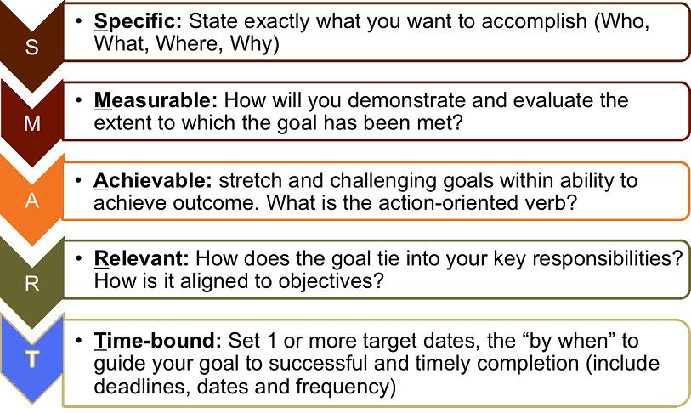
Image from http://plantbaseddietitian.com/wp-content/uploads/2012/12/SMART-Goals.jpg

EXAMPLE:

Not a SMART goal:
- Employee will improve their writing skills.
Does not identify a measurement or time frame, nor why improvement is needed or how it will be used.

SMART goal:
- The organization has identified a goal to improve communications with staff by implementing an internal newsletter. Thembi will complete a business writing course by January 2014 and will publish the first monthly newsletter by March 2014. She will gather input and/or articles from department heads and draft the newsletter for supervisor review, and when approved by CEO, distribute the newsletter to staff by the 15th of each month.

GOAL:
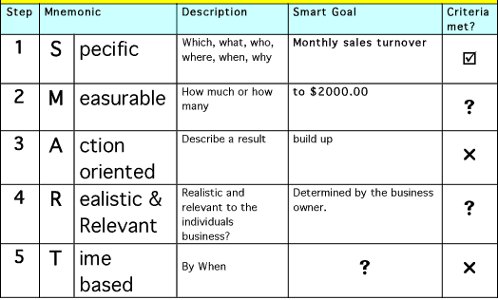
Image from http://www.network-marketing-mlm-success-system.com/smart-goal-setting.html

SMART GOAL:
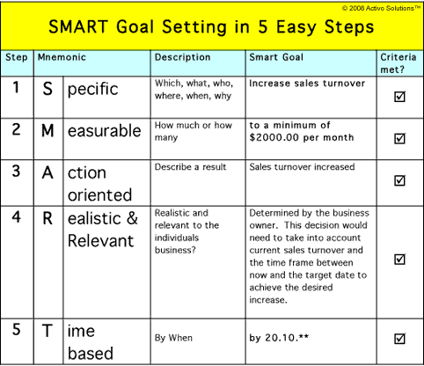
Image from http://www.network-marketing-mlm-success-system.com/smart-goal-setting.html

SMART Goal Planning Form

Specific – WHO? WHAT?

Measurement/Assessment – HOW?

Attainable/Achievable/Actionable – CAN YOU SUCCEED?

Relevant – EXPECTED RESULT?

Timeframe – WHEN?

