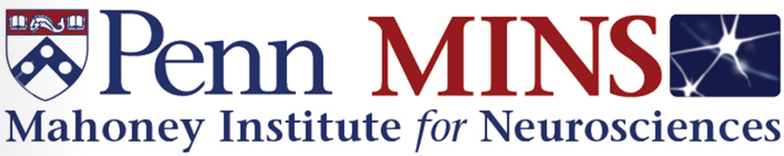
2022 – 2023 Seminar Series
Wednesdays, 4 – 5pm
Class of 62’ Auditorium, John Morgan Bldg.
or Livestream: (Zoom Link)

 | September 14 | Erin Calipari, PhD  Vanderbilt University | Elizabeth Heller
 | September 21 | Arash Afraz, PhD  NIH/NIMH | Catrina Hacker
 | October 12 | Alex Kwan, PhD  Cornell University | Shinjae Chung
 | October 19 | Sika Zheng, PhD  University of California, Riverside | Joe Zhou
 | October 26 | Attila Losonczy, PhD  Columbia University | Theo Tsetsenis
 | November 30 | Piali Sengupta, PhD  Brandeis University | Michael Hart
 | December 7 | Tor Wagner, PhD  Dartmouth College | Gregory Corder
 | December 14 | Cagla Eroglu, PhD  Duke University | Chris Bennett
 | January 11, 2023 | Jose Moron-Concepcion, PhD  Washington University | Heath Schmidt
 | January 18 | Kristina Nielsen, PhD  Johns Hopkins University | Benjamin Scholl
 | February 1 | Jason Shepherd, PhD  University of Utah | Gregory Corder
 | February 8 | Vivek Jayaraman, PhD  HHMI, Janelia Research Campus | Matthew Kayser
 | February 15 | Daniel Wolpert, PhD  Columbia University | Nick Betley
 | February 22 | Ivan de Araujo, PhD  Johns Hopkins University | Amber Alhadeff
 | March 1 | Christina Alberini, PhD  NYU | Sandra Maday
 | March 22 | Yeka Aponte, PhD  NIH/NIDA | Sarah Applebey
 | April 5 | Renata Batista Brito, PhD  Albert Einstein College of Medicine | Marc Fuccillo
 | April 12 | MINS Annual Symposium | “Year of Psychedelics”
 | May 3 | Marco Tizzano, UPenn Dental Medicine | Dean’s Distinguished Visiting Professorship

