PennERA Proposal Certification Instructions for PIs

Email Template:

Subject: PennERA PI Certification Needed (PennERA proposal ########)

Please log in to PennERA and complete the following required forms for the STUDY NICKNAME study, proposal ########:
- Certification by Principal Investigator (Certification)
- SOM PI Research Categorization Form (Certification)

Reply to this email when the forms have been completed so I may submit the proposal for PSOM review.

PennERA Proposal Certification Instruction:

- Go to the PennERA website: https://www.pennera.upenn.edu/

- Log In to Penn ERA by entering you Pennkey.

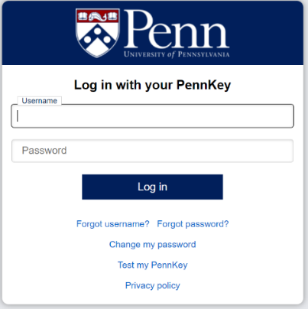

- Complete the Two-Step Verification if needed.

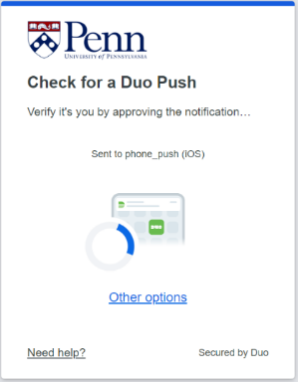

- If you see this page. Click on the portal button to go to the new portal.

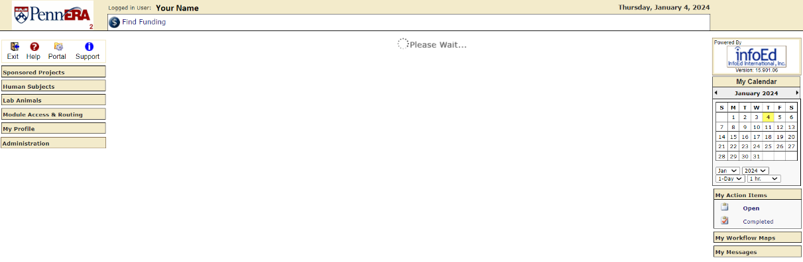

- You should arrive at this page:

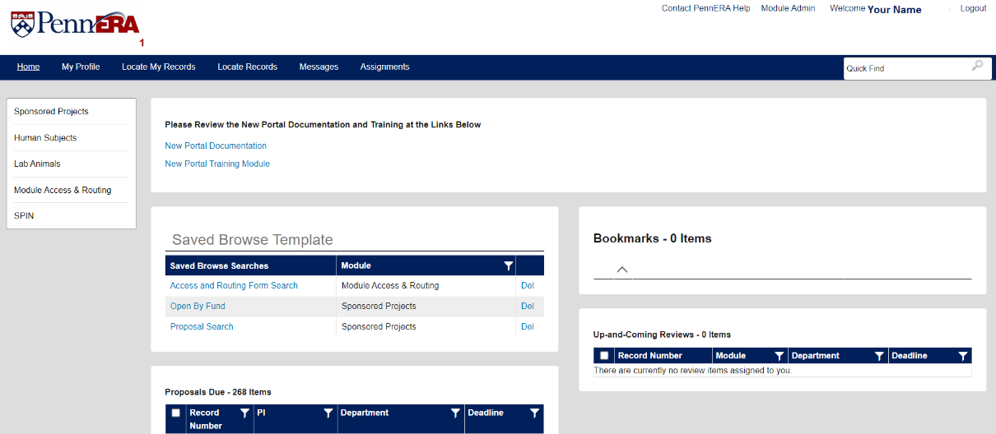

- In the top right corner of the PennERA homepage in the search bar where it says “Quick Find” enter your proposal/record number: ######## and hit enter.

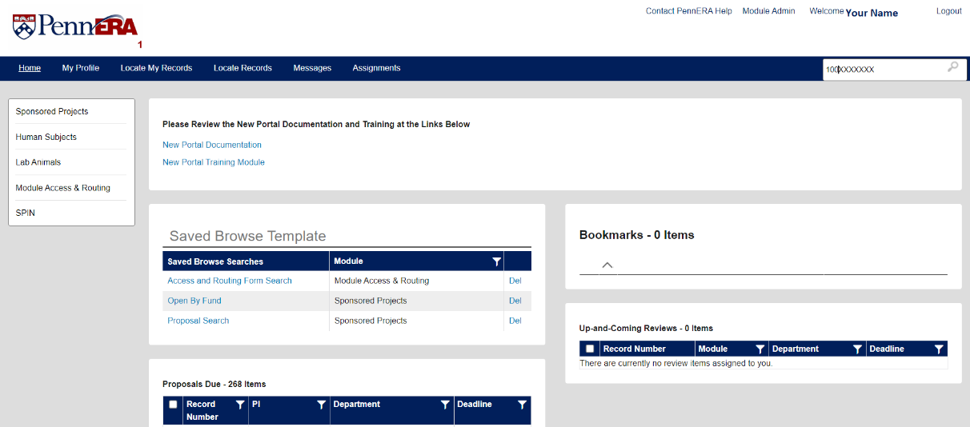

- Your proposal will appear in the search results list.

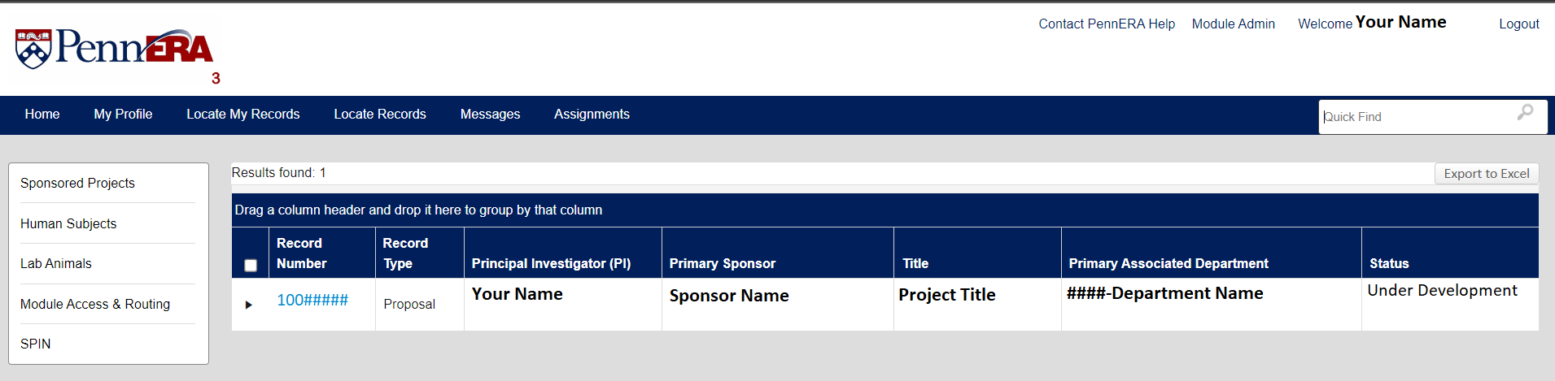

- Click the Blue Record Number to reveal the list of action.

- The list of action will appear.

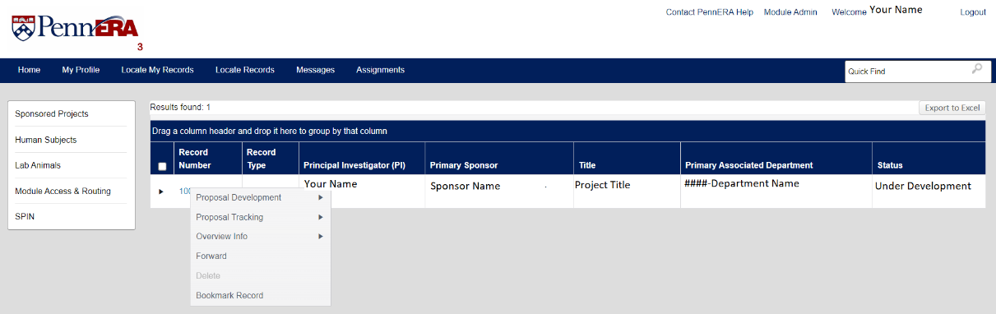

- Mouse over Proposal Development and Click Edit in the list that appears to edit the proposal.

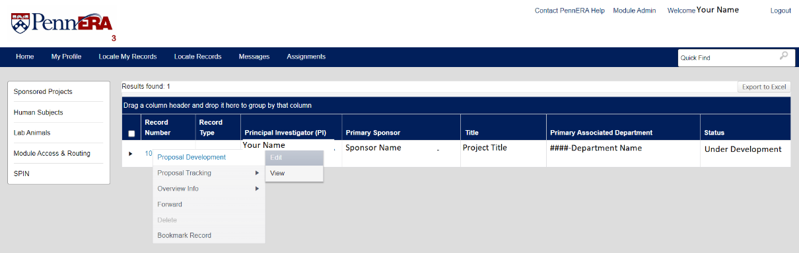

- The proposal will open in a new window. In the left navigation bar select the Internal Documents tab.

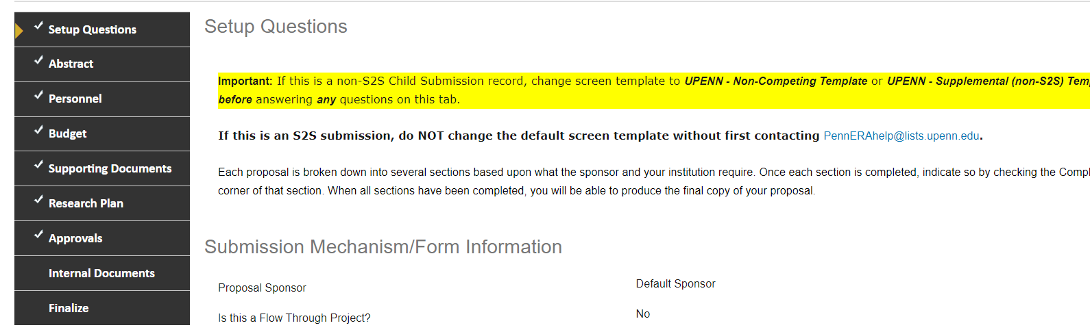

- Click the Pencil and Paper icon next to the Certification by Principal Investigator form. The form will open in a new window.

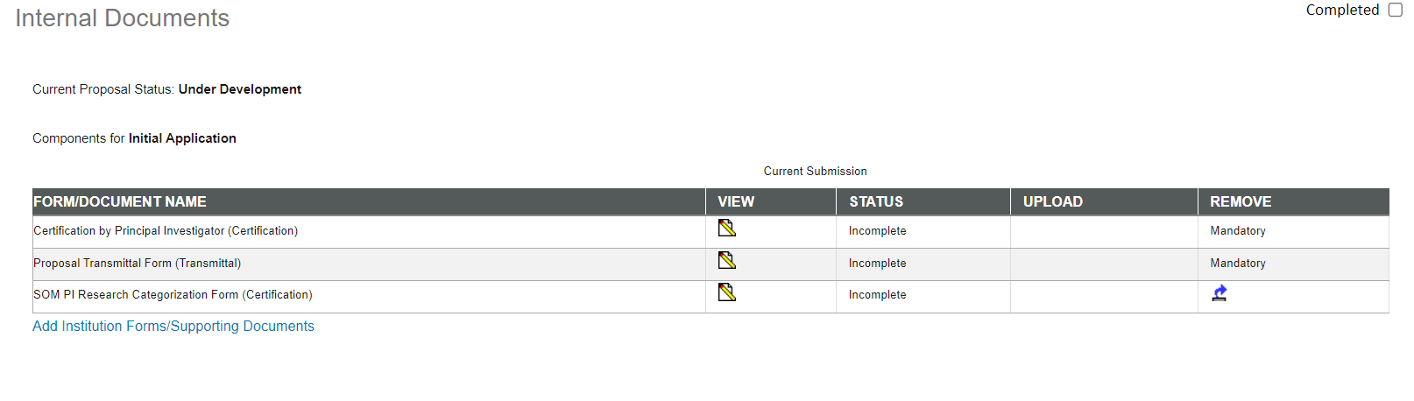

- Complete the required fields (denoted by *), then check the COMPLETE checkbox. Also, please be sure to complete the “Brief Description” field as it will feed into major aims for your other support pages. The form will automatically close.

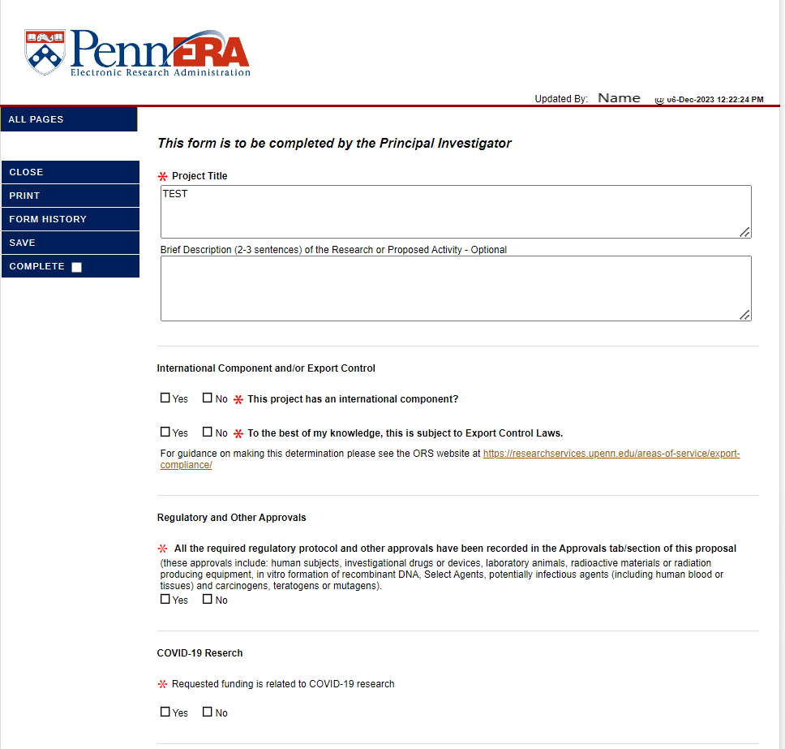

Copy of form text:
This form is to be completed by the Principal Investigator
*Project Title

Brief Description (2-3 sentences) of the Research or Proposed Activity - Optional

International Component and/or Export Control
 | Yes No | *This project has an international component?

 | Yes No | *To the best of my knowledge, this is subject to Export Control Laws.

For guidance on making this determination please see the ORS website at https://researchservices.upenn.edu/areas-of-service/export-compliance/

Regulatory and Other Approvals
* All the required regulatory protocol and other approvals have been recorded in the Approvals tab/section of this proposal (these approvals include: human subjects, investigational drugs or devices, laboratory animals, radioactive materials or radiation producing equipment, in vitro formation of recombinant DNA, Select Agents, potentially infectious agents (including human blood or tissues) and carcinogens, teratogens or mutagens).
Yes No

COVID-19 Reserch
*Requested funding is related to COVID-19 research
Yes No

Certification
Principal Investigator/Project Director

* I certify that no one proposed to work on this project is, to the best of my knowledge, excluded from participation in federally funded activities as a result of government-wide suspension or debarment. (The complete text of the certification may be found at: https://grants.nih.gov/grants/policy/nihgps/HTML5/section_4/4.1.6_debarment_and_suspension.htm)
Yes No

*This project, if awarded, will be funded either directly or indirectly by the Public Health Service (PHS) or one of its agencies (e.g. NIH)
Yes No

Biosketch

All positions, honors, and scientific appointments both domestic and foreign, including affiliations with foreign entities or governments and titled academic, professional, or institutional appointments whether or not remuneration is received, and whether full-time, part-time, or voluntary have been reported in the biosketch.

Other Support

All resources and/or financial support from all foreign and domestic entities made available in support of and/or related to all of my research endeavors, have been included in Other Support regardless of whether or not they have monetary value and regardless of whether they are based at the University of Pennsylvania. This includes, but is not limited to:

* | Financial support for laboratory personnel, and provision of high-value materials that are not freely available (e.g., biologics, chemical, model systems, technology, etc.), whether provided through an MTA or otherwise.

* | Consulting, when the PD/PI or other senior/key personnel will be conducting research as part of the consulting activities.

* | In-kind contributions, e.g., office/laboratory space, equipment, supplies, or employees or students, supported by an outside source or material amounts of equipment or supplies for research.

*I understand Federal and other sponsor requirements for disclosing other/current and pending support, whether in-kind or monetary and provided through Penn, another organization, or directly to me, as well as positions, honors, appointments, and affiliations. I certify that I have made the appropriate disclosures and will verify that key personnel listed on my project understand the requirements and agree to comply.
Yes No

*In accordance with the Patent and Tangible Research Property Policies and Procedures of the University of Pennsylvania, all personnel on this project, including postdocs, students and visiting scientists, will have signed Participation Agreements prior to the initiation of this project. (Call the Penn Center for Innovation, 898-9591, for information on inventions, patents, copyrights, etc.)
Yes No

*I certify that the above information on this form and included in this proposal record is true, accurate and complete as of this date. I understand that any false, fictitious or fraudulent statements or claims may subject me to criminal, civil or administrative penalties. I agree to accept responsibility for the conduct of this project and for provision of required reports if a grant or contract is awarded as a result of this application. If an award is made, I will administer it in accordance with the policies of the sponsor and the University.
Yes No

- Click the Pencil and Paper icon next to the SOM PI Research Categorization form. The form will open in a new window.

- Enter the approximate percentage of the research budget to the correct category, then check the COMPLETE checkbox. The form will automatically close.
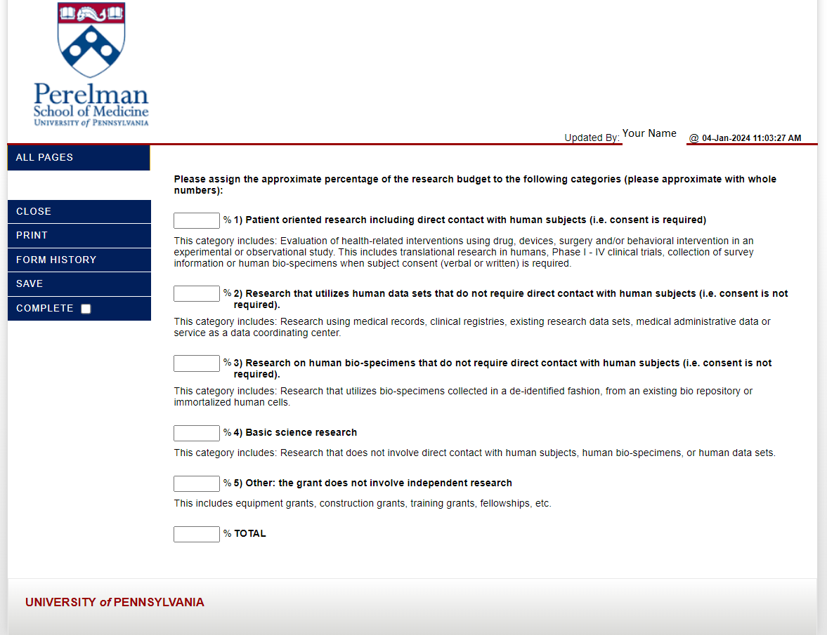

- Click Done in the upper left to close the proposal.

- Click Logout to leave PennERA

- Email your grants manager/coordinator that you have completed the certification forms. They will continue with the submission process.

