SOMERA USER’S GUIDE

Login at http://www.med.upenn.edu/apps/somera with PennID username and password.

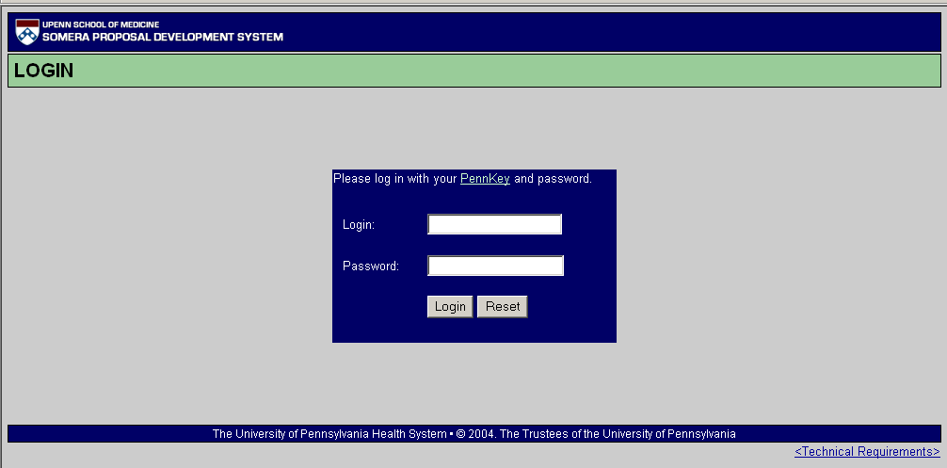
Click here to see browser and system requirements and important notes, or go to http://www.med.upenn.edu/apps/somera/help/browser.html.

IMPORTANT POINTS TO REMEMBER:
• SOMERA times out after 2 hours of inactivity. If the current screen was not saved (see below for description of how to save), data entry will be lost even though all appears OK on the screen. Notification of the time-out doesn’t occur until some other action is taken by the user.
• SOMERA saves simply by taking any action to navigate to another screen or by selecting one of the functions available at the top left on each screen of the tabbed interface.
• Navigate only by using SOMERA’s navigation buttons – don’t use the browser back and forward buttons. Using the browser navigation buttons can cause duplicate actions to occur.
• Almost all data in SOMERA is user-editable, even auto-populated data, until online-submitted to ORSS. Once submitted, only ORSS can make changes to data.
• Once a faculty member’s name and role (PI or sponsor) has been selected, that information cannot be changed after the intent screen has been submitted.
• All access is either role- and/or ORG-based. For examples, those with BA (role) access can see only those ORGs which have been identified for them by ORSS.

BA Home Screen

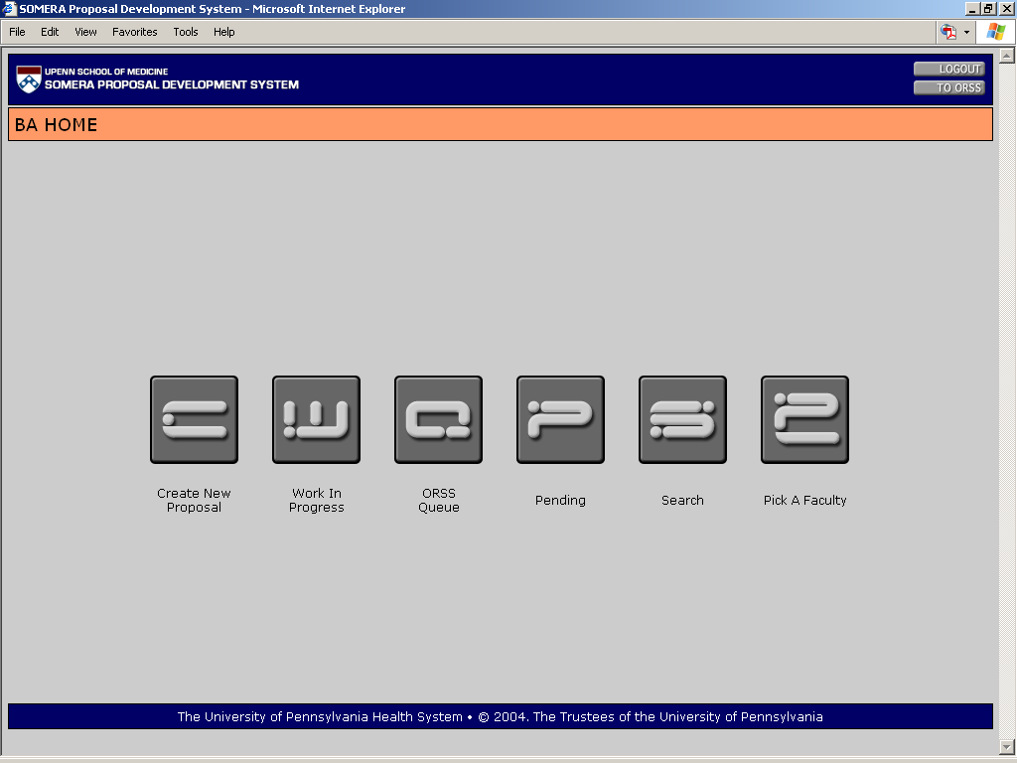
Click here to create a new record. Also called “intent” or “intent to submit” screen.
Click here to see the current queue of unsubmitted proposals.
Click here to view the ORSS work queue. These are proposals that have been online-submitted and are in some stage of the review process.
Click here to see all proposals that have completed the review process and have been logged out of ORSS.
Click here to select search criteria and find specific records.
Click here to view current activity (up to 30 days after log-out) for a particular investigator.

Intent Screen

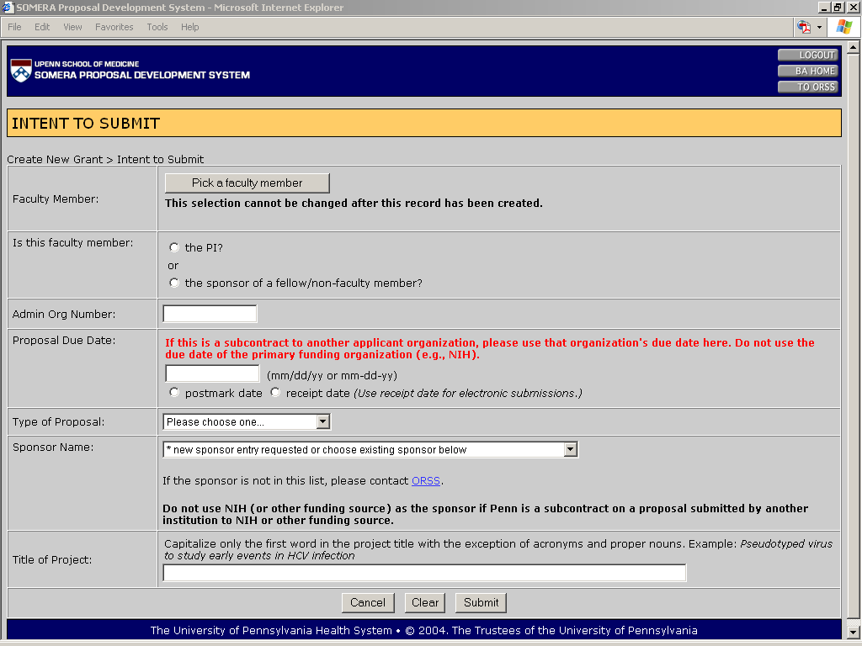
IMPORTANT TO REMEMBER!
See below for a screen shot of “Pick a faculty…”
• Create new records.
• Minimum data set required to create.
• All data is editable in tabbed interface except that the faculty member name and role (PI or sponsor) may not later be changed.
• Below is a screen shot of the faculty look-up screen.
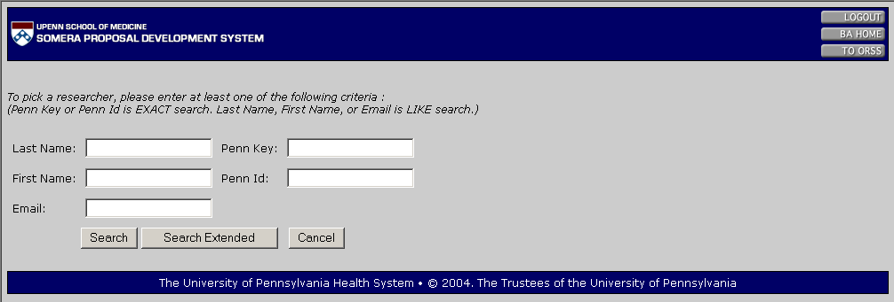
If the researcher’s name is not returned in the first search results, click on ‘Search Extended’.

Intent Screen Warnings!!!
• Warning screens are displayed when the faculty member’s role is identified as sponsor or when a nonfaculty member as been entered with a role identified as PI.
• PLEASE read the warnings and call ORSS before submitting online.

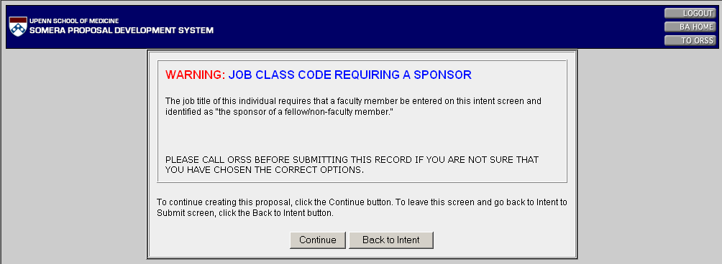
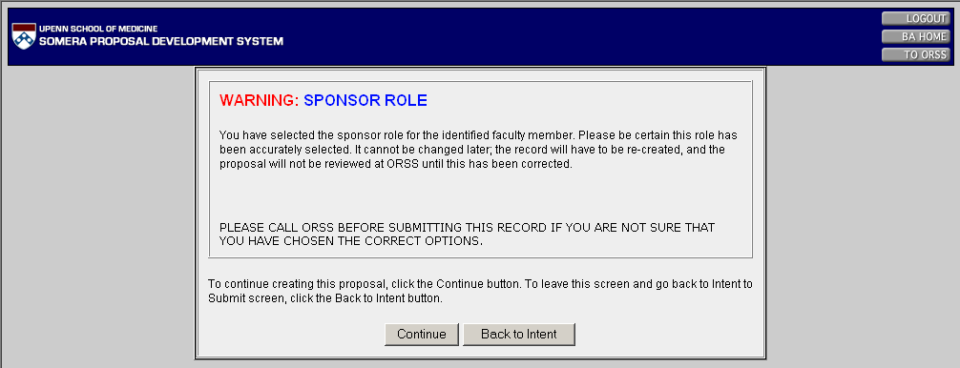
Note the option to return to the Intent screen to change the information before submitting the new record.
PLEASE DO NOT CONTINUE WITHOUT PRIOR CONSULTATION WITH YOUR ORSS GRANTS SPECIALIST.

Tabbed Interface
These navigation buttons (“tabs”) – below and to the right – are available on every screen. Remember to navigate from screen to screen using only these buttons.
These functions (see drop-down list below) are available on all screens in the tabbed interface.
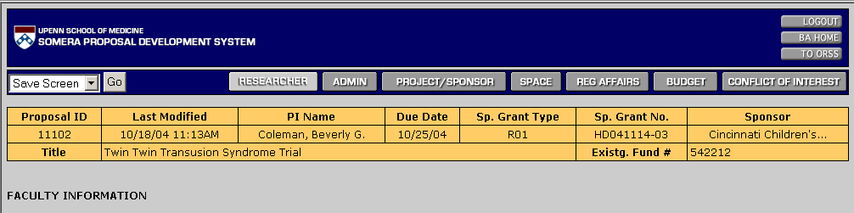
Data in the boxes above is shown on each screen so that the user knows which record is being edited.

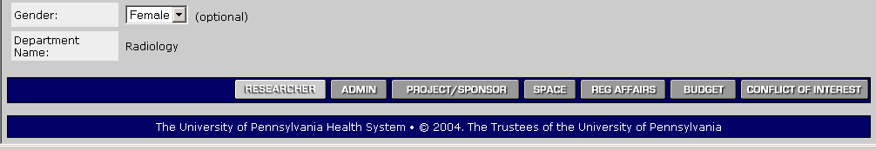
Navigation buttons are also available at the bottom of each screen to avoid the need to scroll back to the top in order to navigate to the next screen.

Functions:

The functions in the drop-down list are available on all tabbed interface screens.
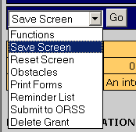
Save Screen – Save data on screen without moving to another screen; useful to avoid data loss if SOMERA times out.

Reset Screen – Clears data to previous saved version.

Obstacles – Displays a list of missing data, identified by screen, that will prevent online submission to ORSS.

Print Forms – Print available forms (transmittal, PHS398 or PHS2590 face page, if applicable); prints only draft versions until online-submitted, then prints final versions. Also prints obstacle and reminder lists.

Reminder List – Important things to do off-line, e.g., obtain PI’s initials for Conflict of Interest section on page 2 of the transmittal.

Submit to ORSS – Finalize data and submit to ORSS.

Delete grant – Deletes the entire record; BAs can delete until online-submitted.

Researcher Tab (Faculty Information as PI or Faculty Sponsor and Non-Faculty Researcher Information Screen)
• Most information about the PI and/or faculty member sponsor is auto-populated from databases external to SOMERA.
• Most information is user-editable, but the faculty member’s name and role (PI or sponsor) cannot be changed after the initial intent-to-submit screen is created.

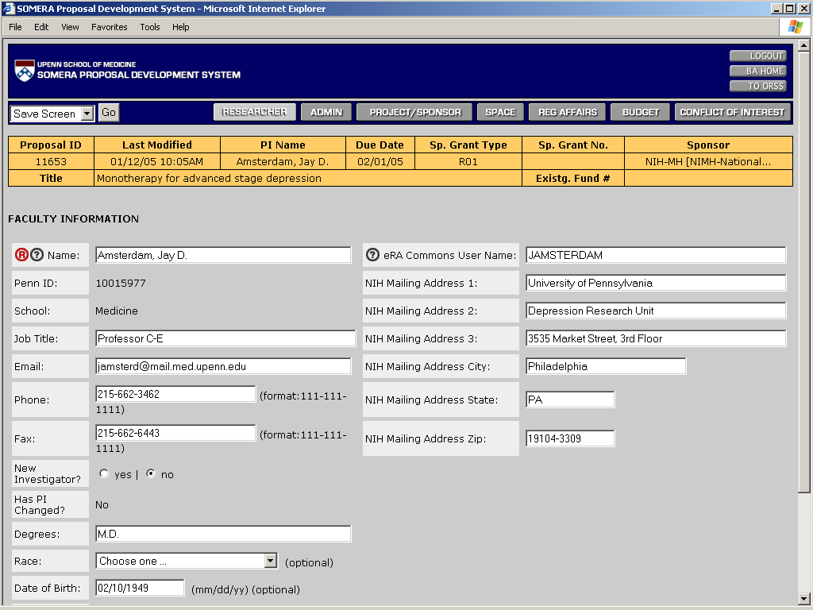
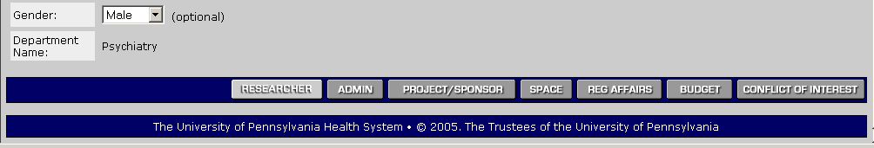
• A second section is automatically added by SOMERA when the faculty member is not the PI but is the sponsor of another non-faculty member who is the PI.

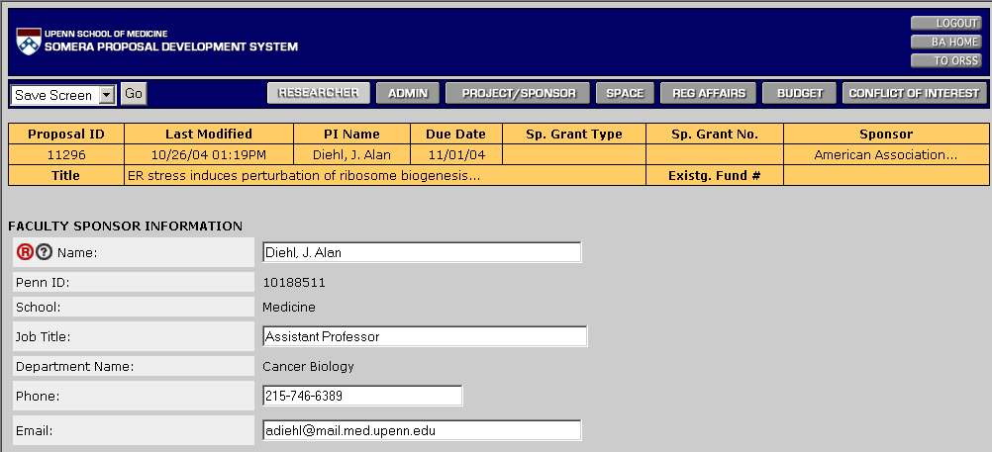
Only the minimum information necessary for the transmittal is displayed for the faculty member identified as the sponsor.
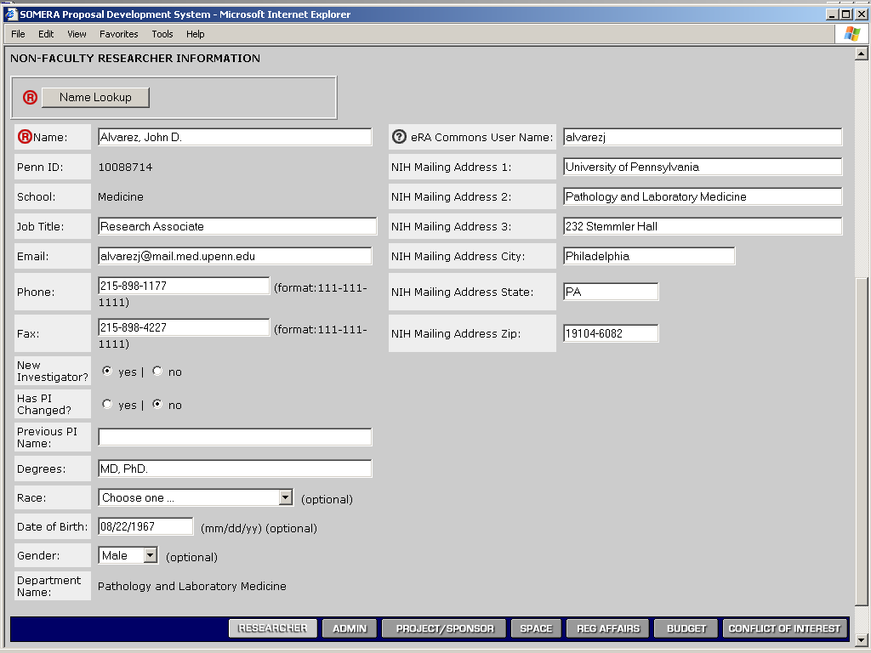
The Name Lookup button is clicked to find information for the non-faculty member who is identified as the actual PI of the project. See also Page 3 for a screen shot of “Name Lookup”.

Admin Tab (Administrative Information Screen)
• Information related to the administration of the project is listed here.
• Most information is user-editable, but the faculty member’s name and role (PI or sponsor) cannot be changed after the initial intent-to-submit screen is created.

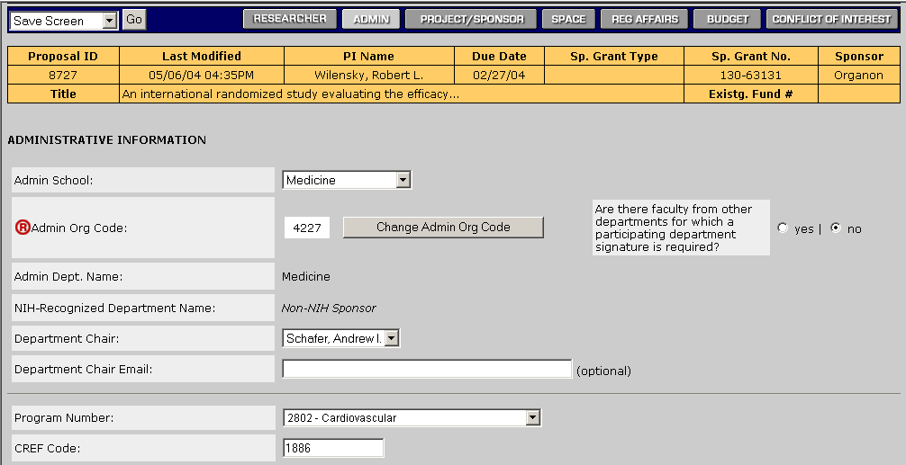
“TBA” (without quotes) may be entered in CREF field if a CREF has not yet been assigned to the PI.
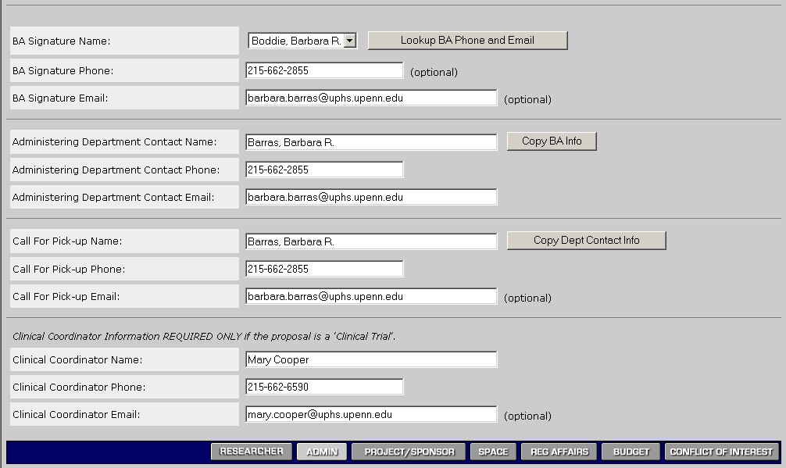

Project/Sponsor Tab (Project, Sponsor, and PHS2590 Information Screen)
• Information related to the project and sponsor is provided here by the BA.

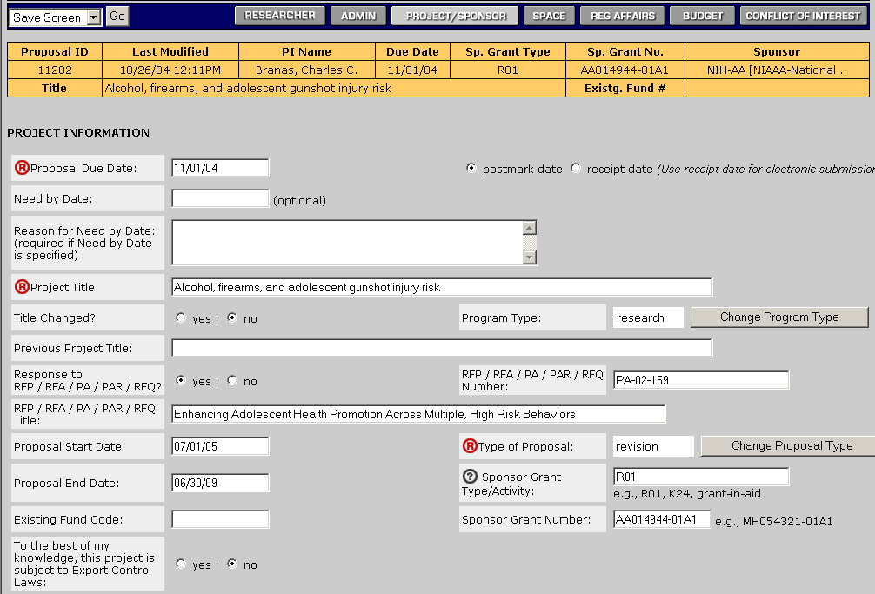
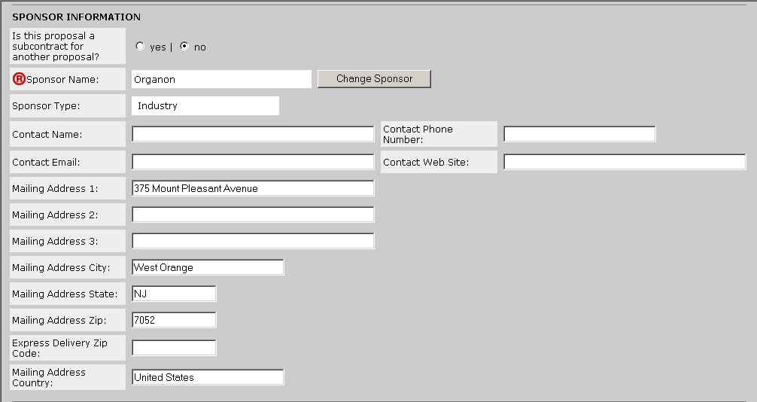
• If the proposal is a noncompeting for an NIH award (or subcontract to an NIH award), additional information is requested in order to complete the PHS2590 face page.

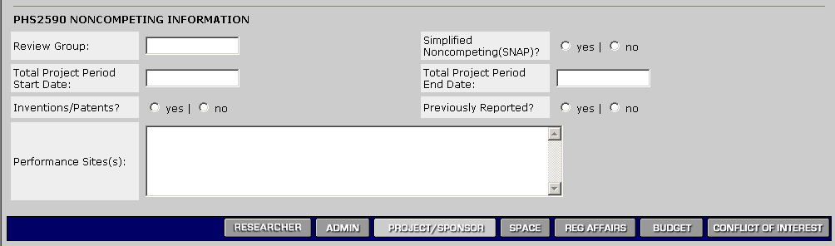

Space Tab (Space Information Screen)
• Information about space required for the project is entered here.
• Information is concatenated from the SOMERA space screen to the appropriate sections on the transmittal.

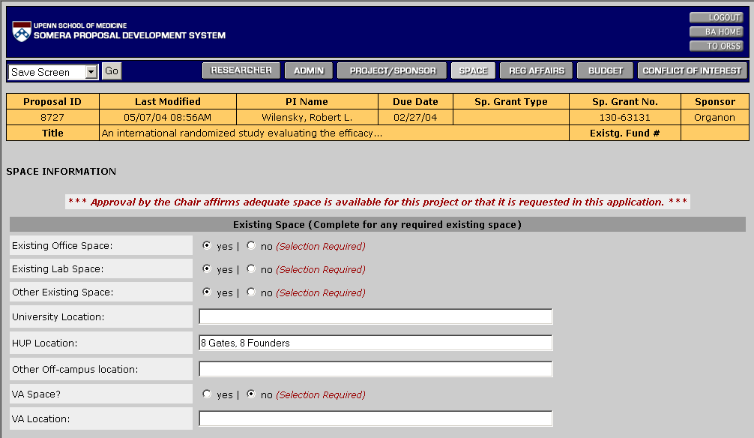
BAs must answer “yes” or “no” to each question – there are no default answers provided by SOMERA.
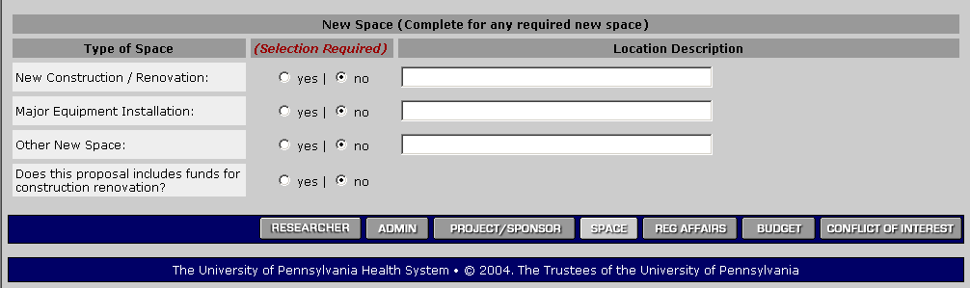

Reg Affairs Tab (Regulatory Affairs Information Screen)
• Information about all regulatory affairs issues is provided by the BAs on this screen.
• Business rules are in place to require only the minimum necessary responses. For example, new projects can list animals as “pending” – no other information is required.

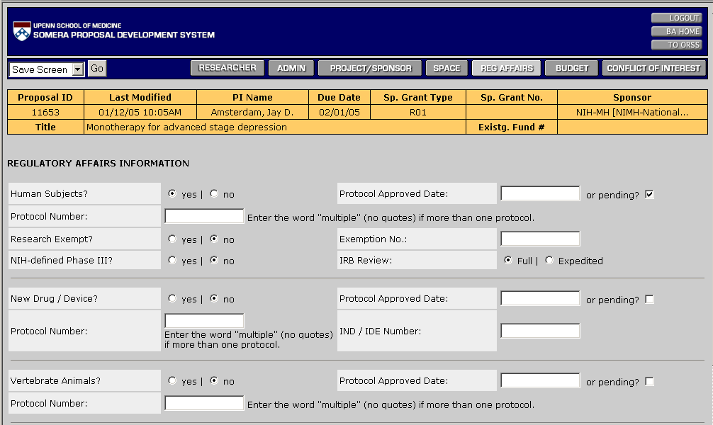
BAs must answer “yes” or “no” to initial question of each section, but other answers are required only in response to “yes” answers.
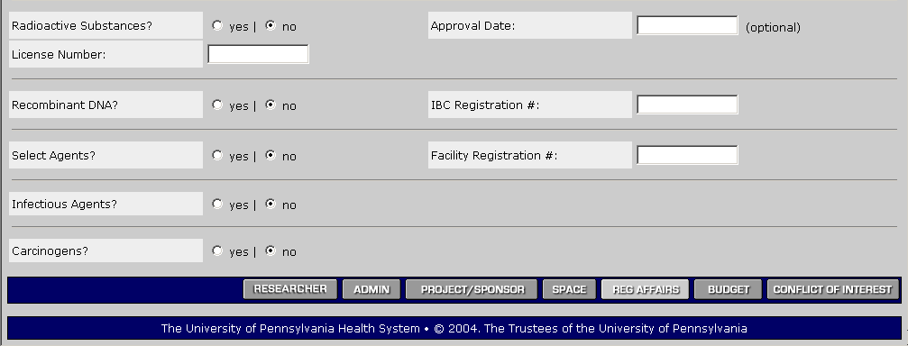

Budget Tab (Budget Information Screen)
• Information about budget, cost-sharing, and subcontracts is provided by the BAs on this screen.

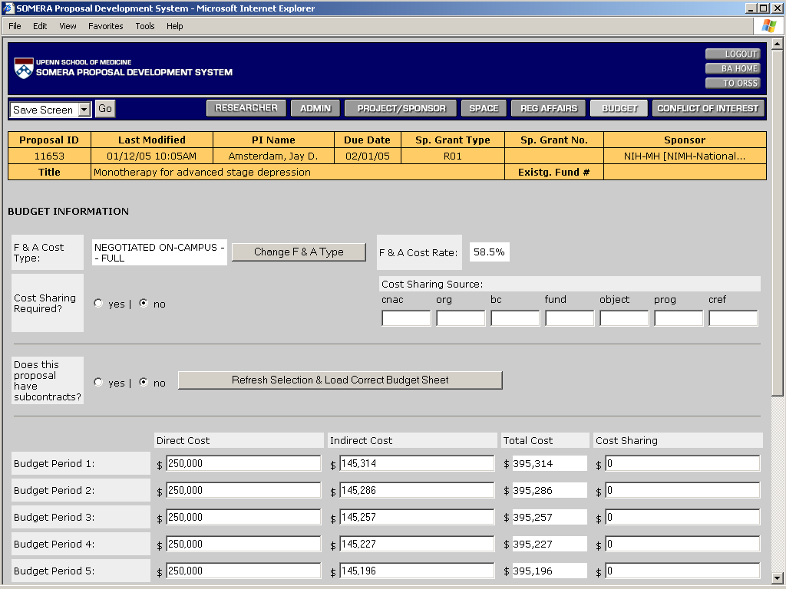

• The number of budget periods displayed (see below) is determined by the project period dates.

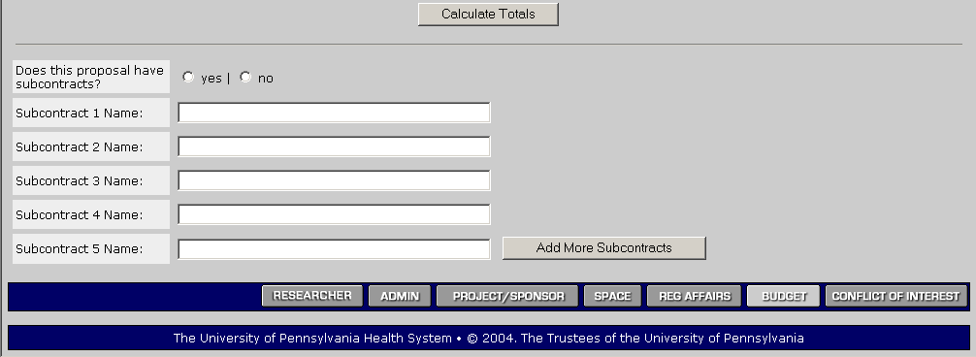
Budget Totals are automatically cal-culated by clicking “Calculate Totals”.
Up to 20 subcontracts, 5 at a time, can be listed by clicking here.
• NIH (or NIH-type) proposals with subcontracts will display the following budget fields:

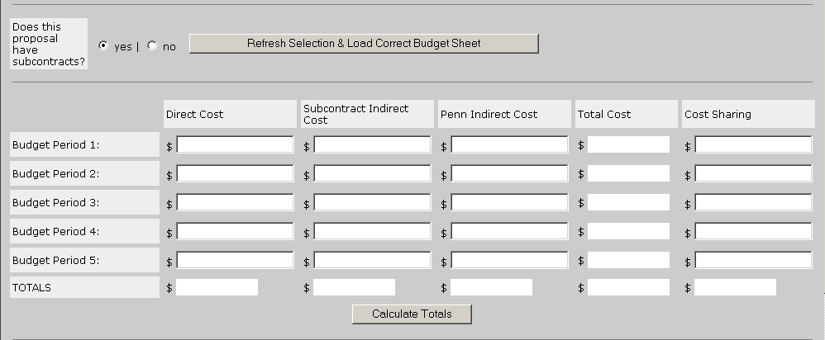

• When the above budget screen is needed, the screen on the next page is displayed when the budget table is refreshed.
• Note that this information is printable for reference.
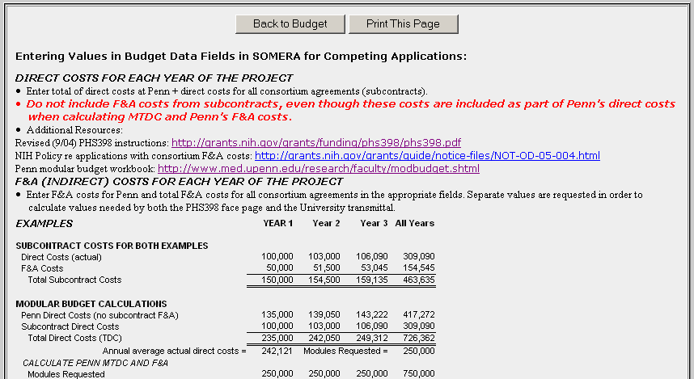
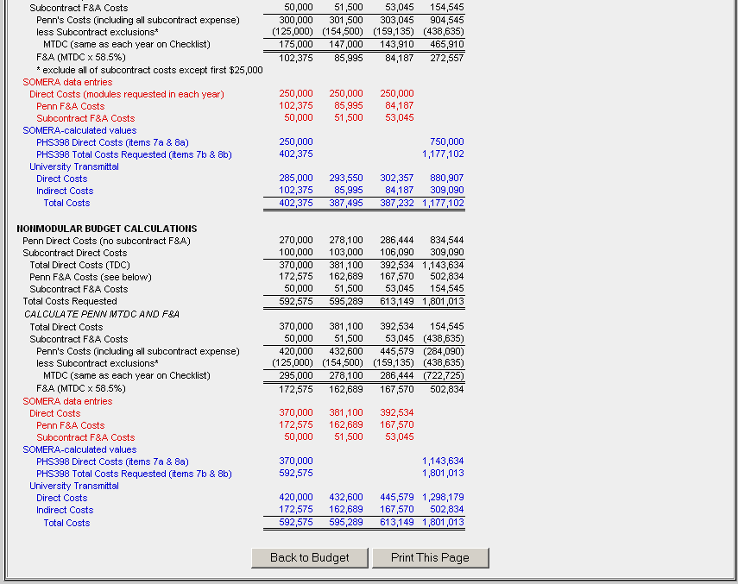

Conflict of Interest Tab (Screen)
• This information is provided as a convenience only at this time.
• BAs cannot click the “yes” or “no” buttons.
• This section could become available for editing to PIs in the future when electronic signatures are added.

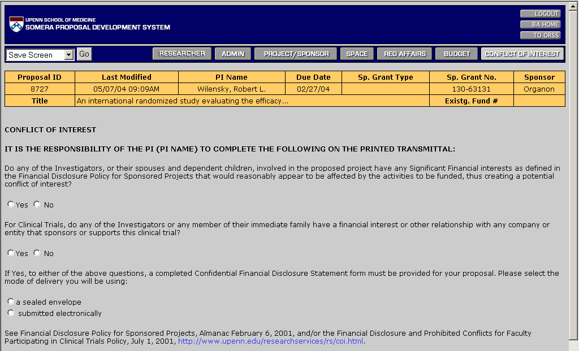

Obstacles
• To display any obstacles to submitting proposal online, click on Function drop-down list (upper left corner), select “Obstacles”, then click on “Go”.

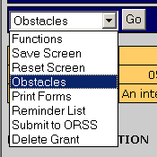

• For this particular proposal, the only obstacle is displayed below:

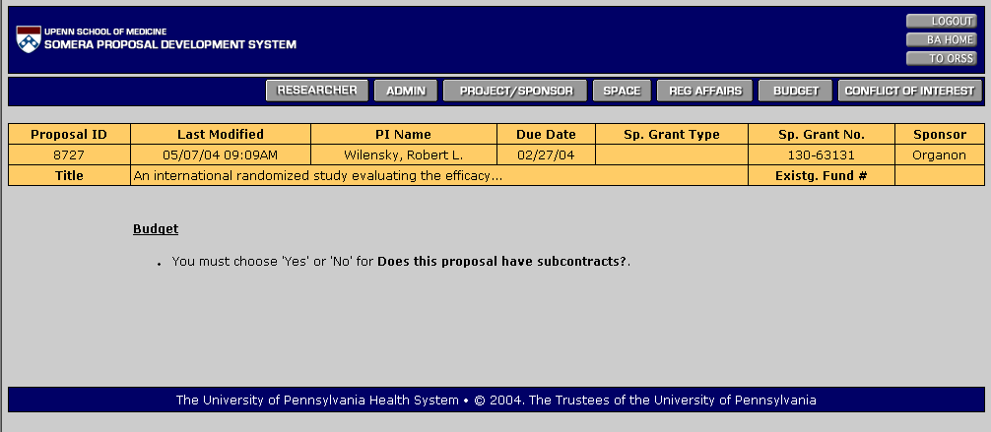

Reminder List
• To display reminders, click on Function drop-down list (upper left corner), select “Reminders”, then click on “Go”.

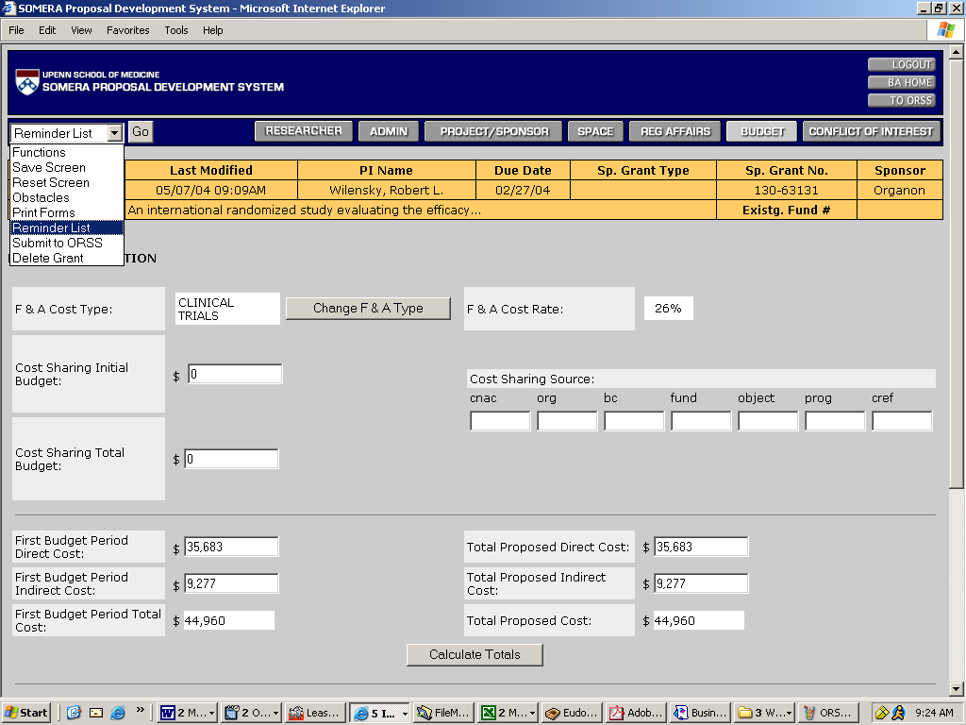

• These are the reminders; the list can also be printed:

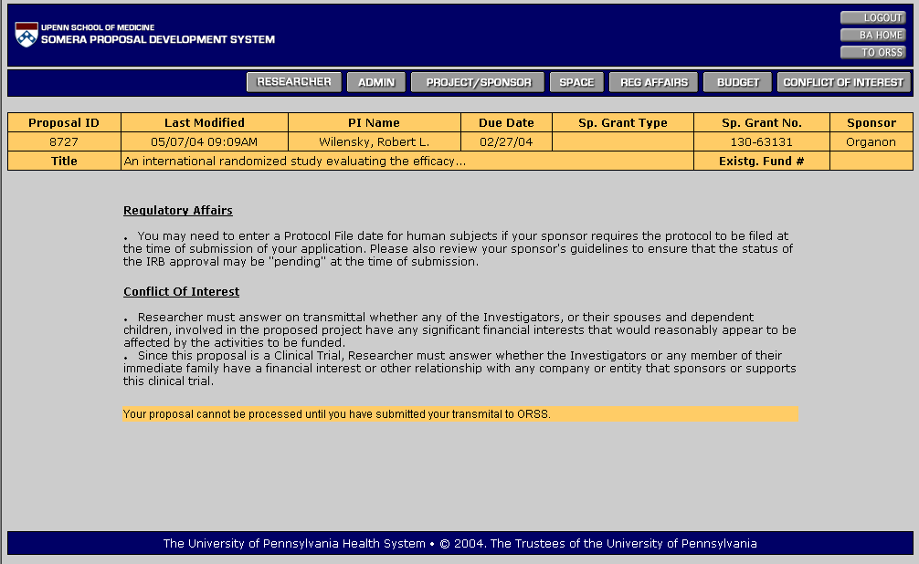

Print Forms
• To print forms, click on Function drop-down list (upper left corner), select “Print Forms”, then click on “Go”.
• Only draft versions are available prior to choosing “Submit to ORSS”. Once online-submitted, data is no longer editable by BAs.

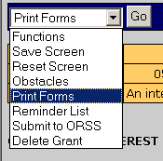

• Draft documents are not accepted by ORSS for review.

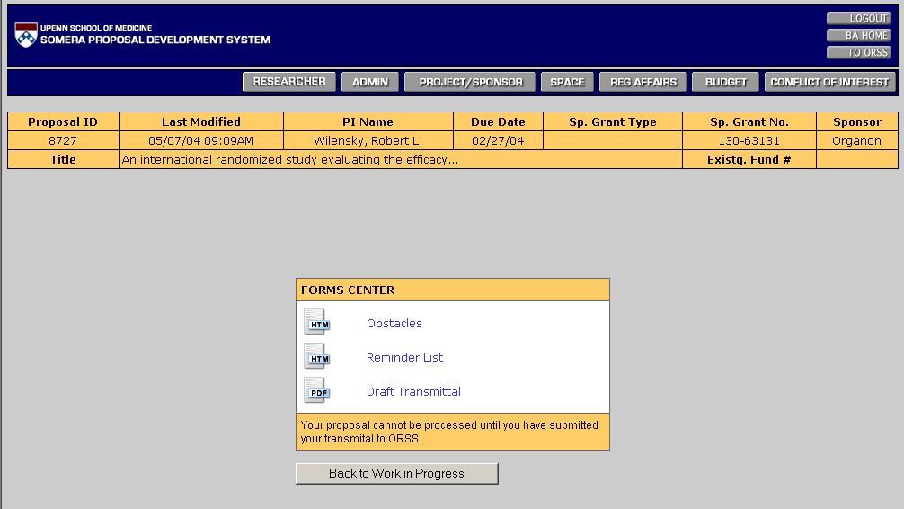
Print screen for non-NIH proposal that has not yet been online-submitted to ORSS: Only a draft version of the transmittal is available for printing.
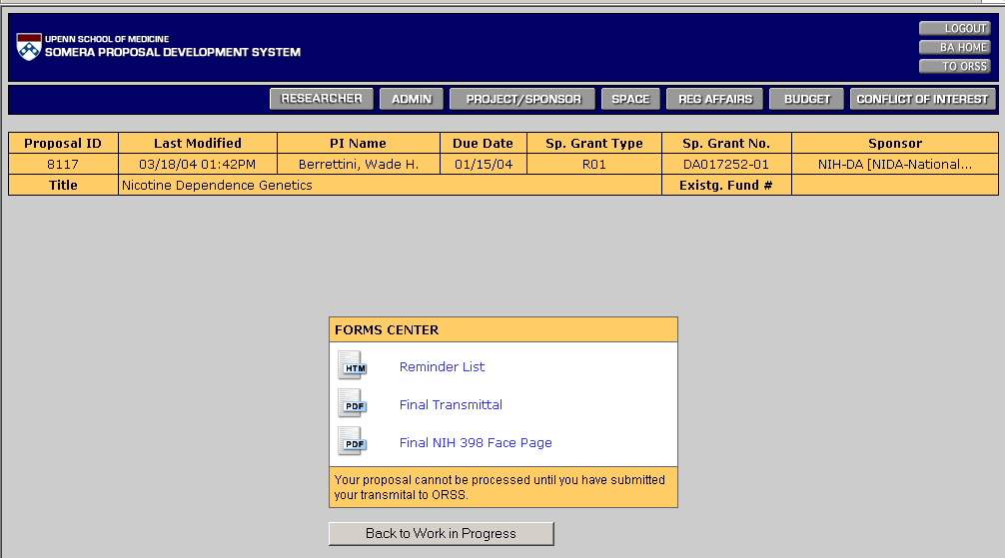
Print screen for NIH proposal that has been online-submitted to ORSS: Only final versions of the transmittal and PHS398 face page are available for printing.

• Documents can be printed at any time by any authorized user, even after online-submit.
• The view below is available from the ORSS Queue, Pending, or Search options on the BA Home Screen (see Page 2).

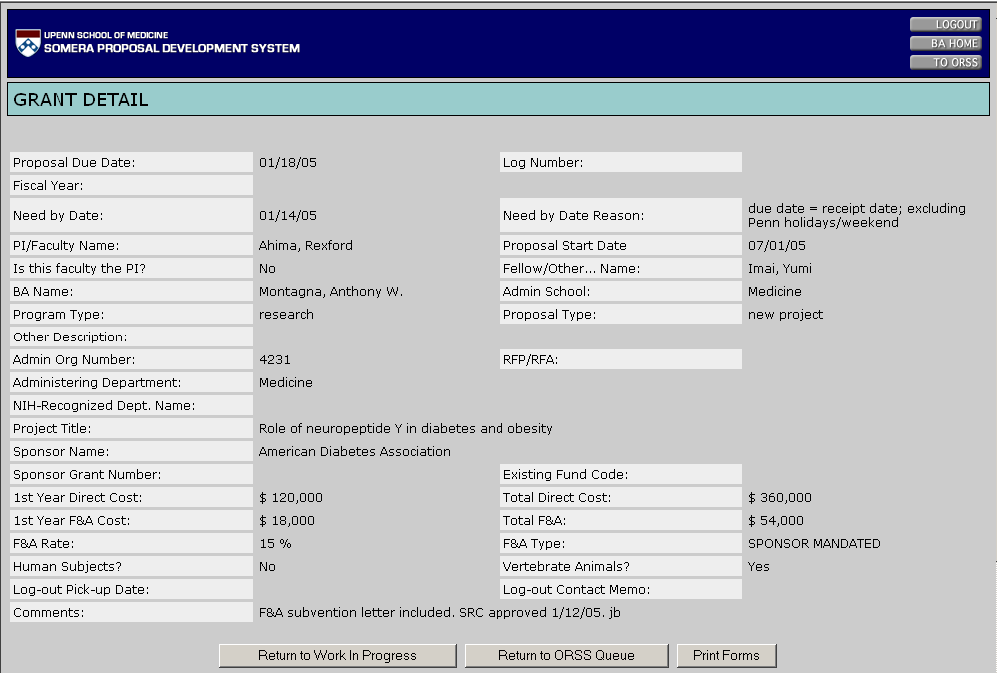
Choose ‘Print Forms’ is one needs to be reprinted after online-submitted to ORSS.

Search Forms
• From “BA Home” screen, click on “Search” button.
• The top part of the form lists search parameters.

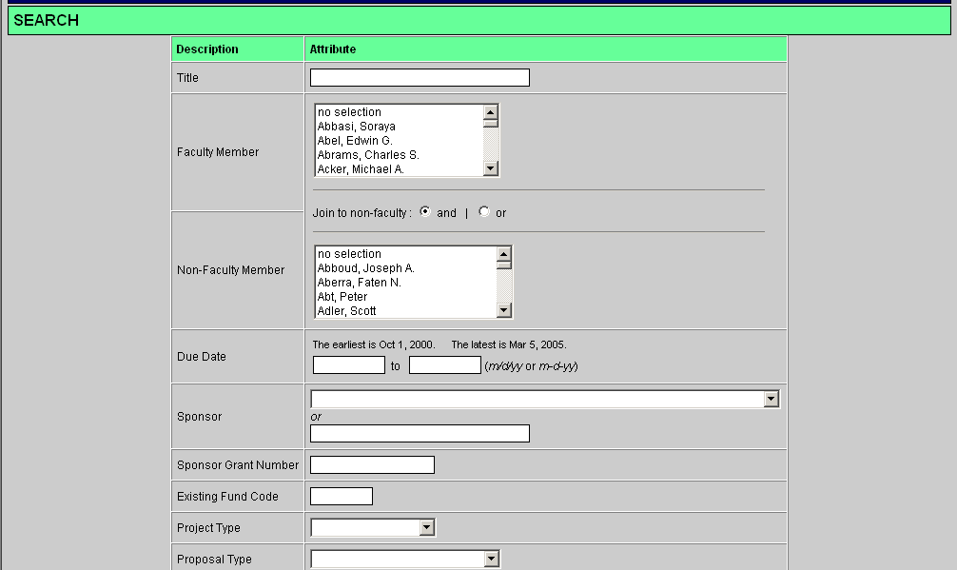
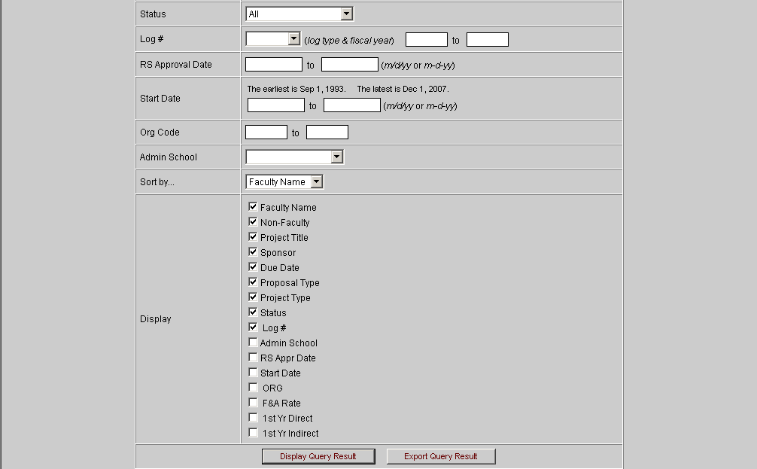
Use this section to choose which values to display in results.

View Faculty-Specific Workflow
• From “BA Home” screen, click on “Pick a Faculty” button.
Click here to view current activity (up to 30 days after log-out) for a particular investigator.

• Enter any of the known values and click on ‘Search’.
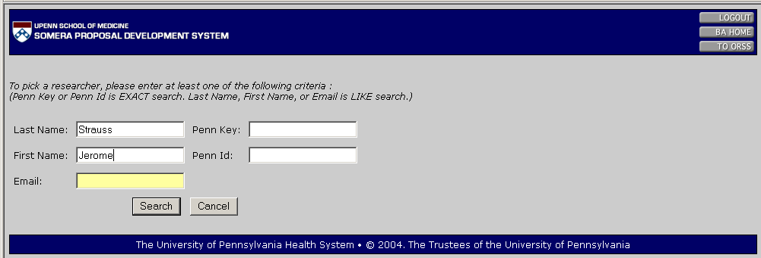
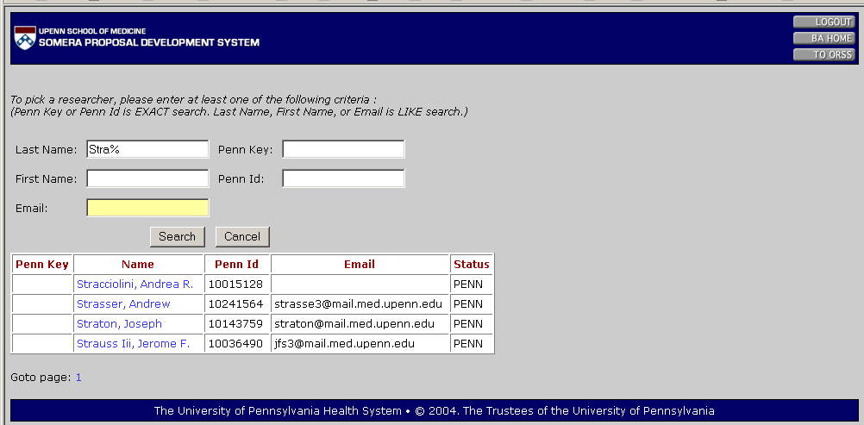
Can use ‘%’ as wildcard. Choose from displayed list.
(See next page for search results.)

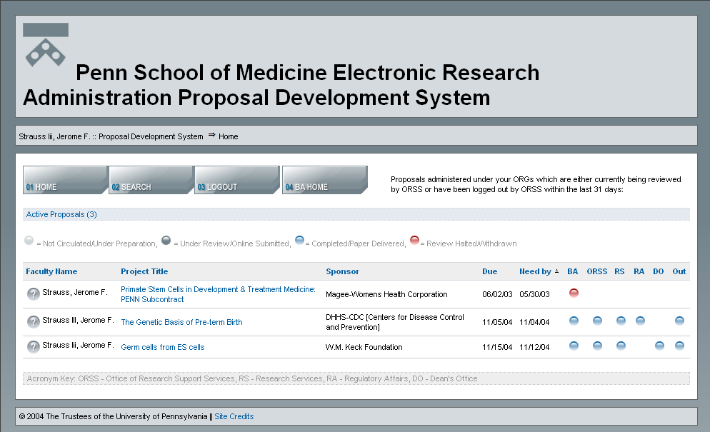
Key to review status displayed in columns below.
• Displays all proposals reviewed (or actively under review) by ORSS for the past 31 days for the name chosen.
• Click ‘Search’ button on this screen to display additional records related to this investigator.
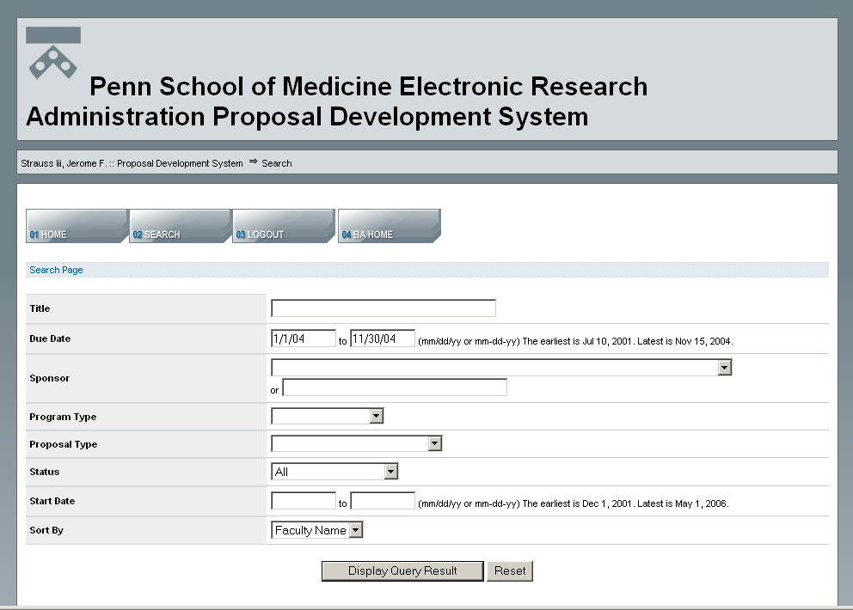
Enter search parameters to broaden previous search results.
